Layered Arrangement

Definition
# Source: AI Source: Provided by: [Data Path: Persons Table -> ID Column: 1, Name_En Column: Motasem Essam] -> From: [ChatGPT] on [7/25/2026]
A Layered Arrangement is a type of composite solid arrangement in which two or more solid components are organized in successive layers, with each layer positioned above or below another layer.
The components may have identical or different shapes and dimensions. They may also be aligned vertically, offset horizontally, or arranged in patterns across multiple layers.
A layered arrangement commonly forms a single three-dimensional structure through the addition and connection of repeated solid components.

Simple Definition
# Source: AI Source: Provided by: [Data Path: Persons Table -> ID Column: 1, Name_En Column: Motasem Essam] -> From: [ChatGPT] on [7/25/2026]
A layered arrangement is a composite solid made by placing multiple solid components in successive levels, one layer above another.

Geometric Representation
# Source: AI Source: Provided by: [Data Path: Persons Table -> ID Column: 1, Name_En Column: Motasem Essam] -> From: [ChatGPT] on [7/25/2026]
A layered arrangement can be represented using several repeated solids, such as cubes, rectangular prisms, cylinders, or mixed shapes.
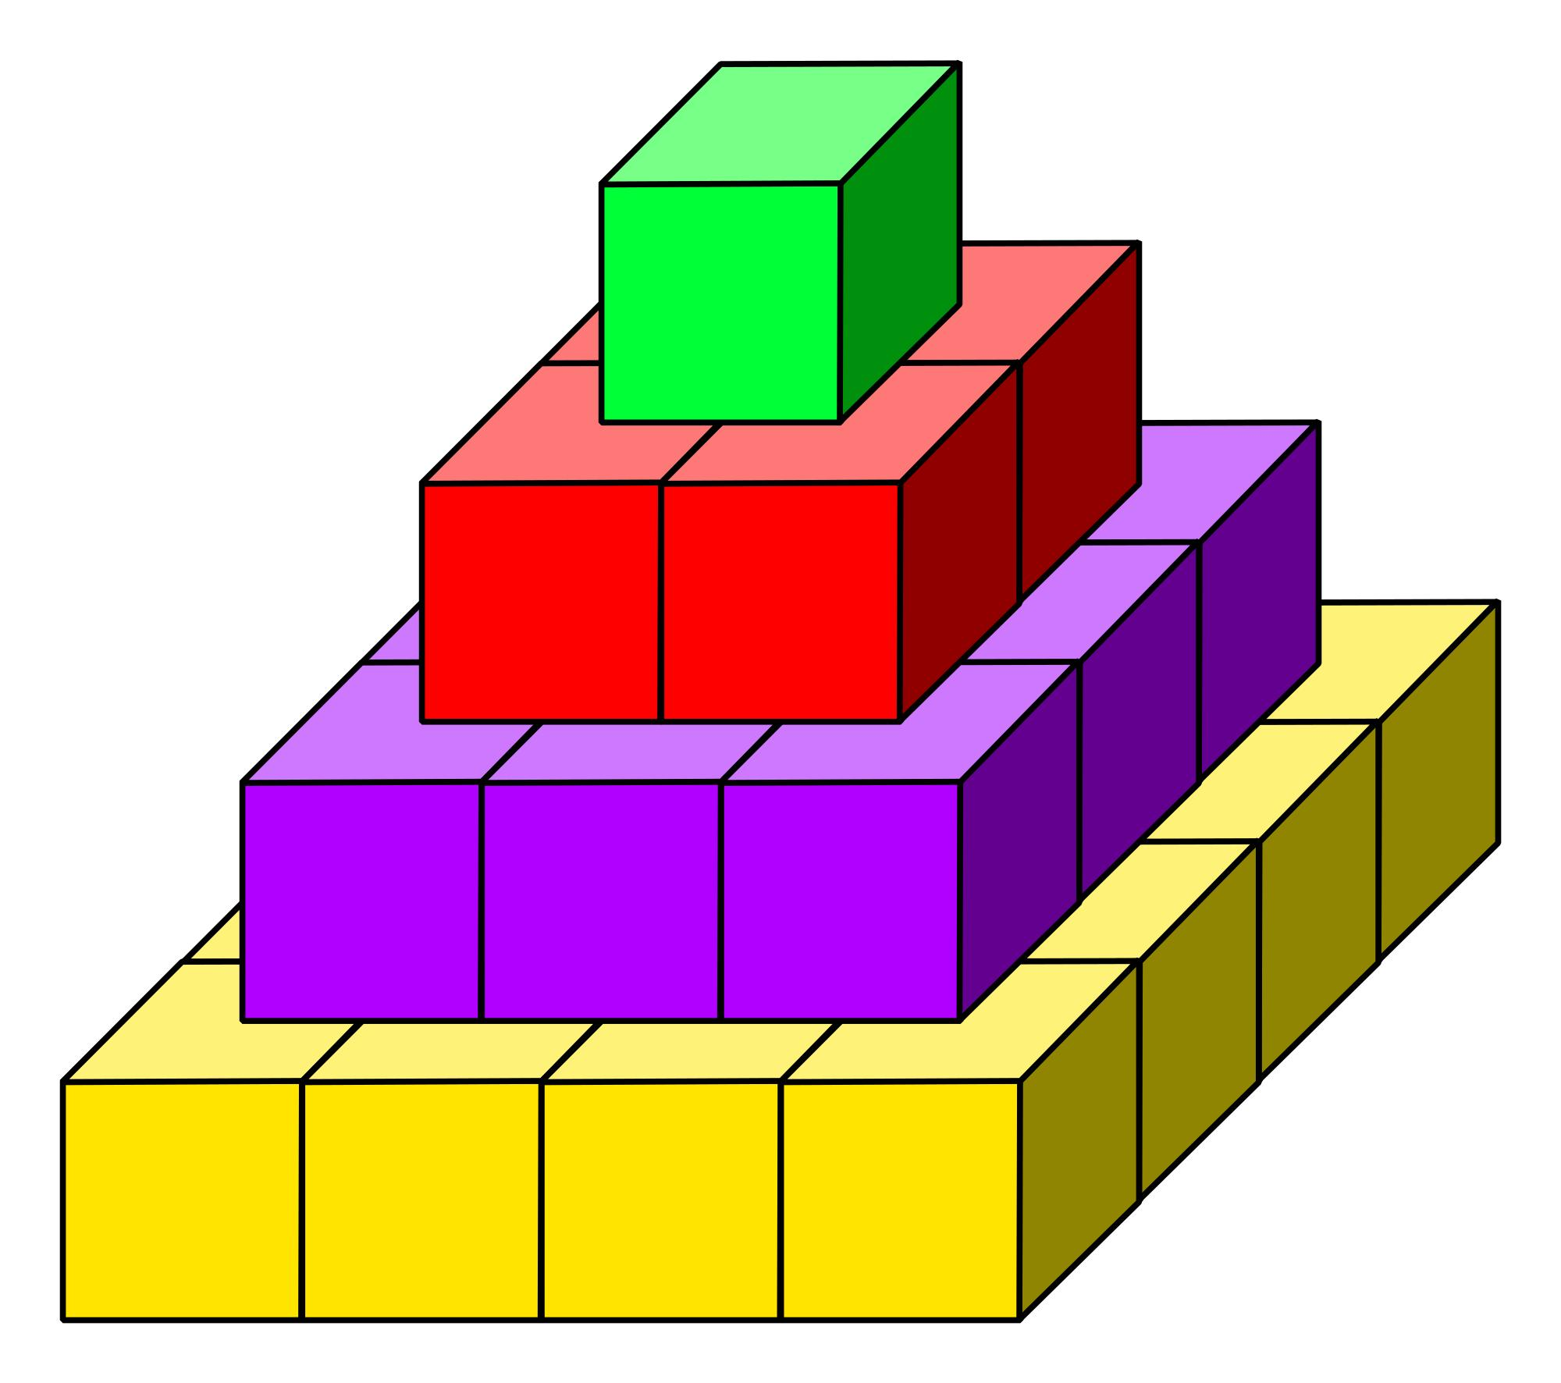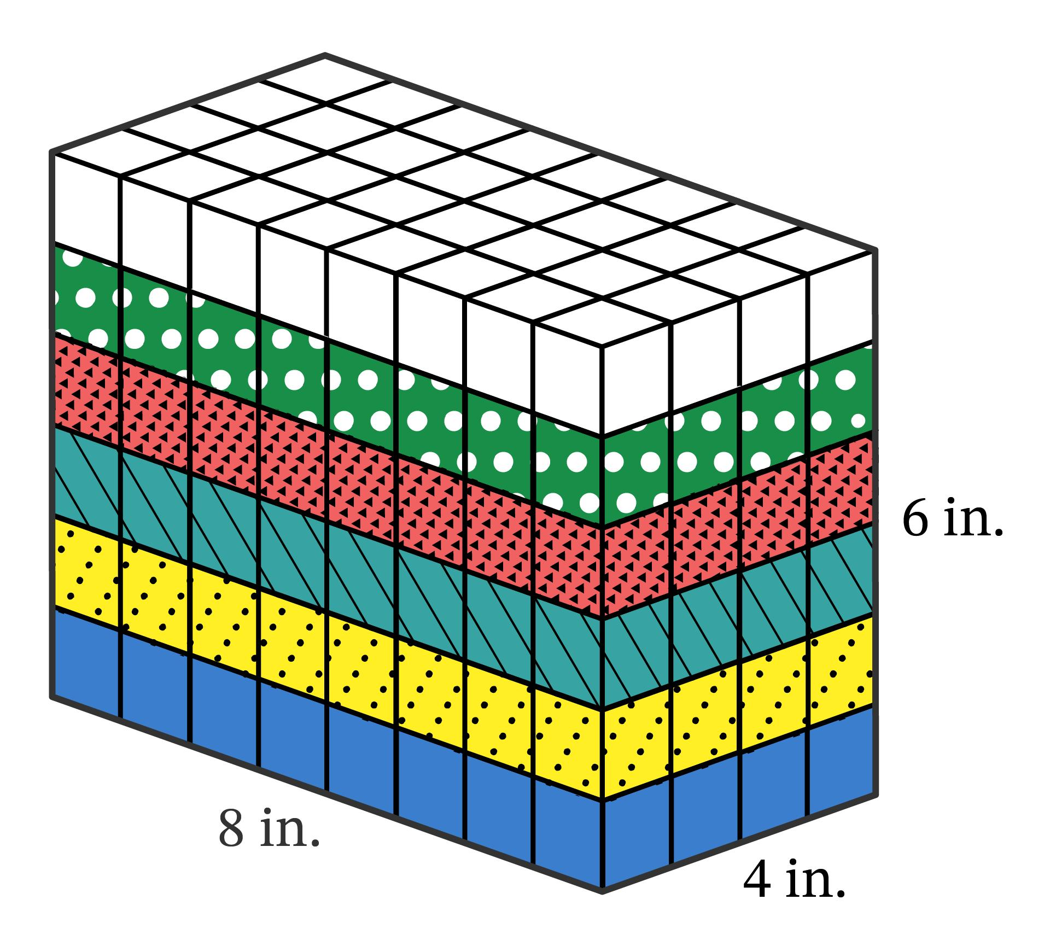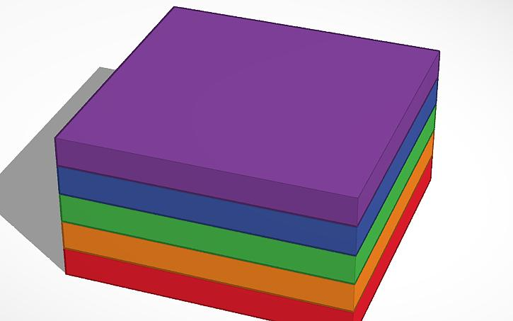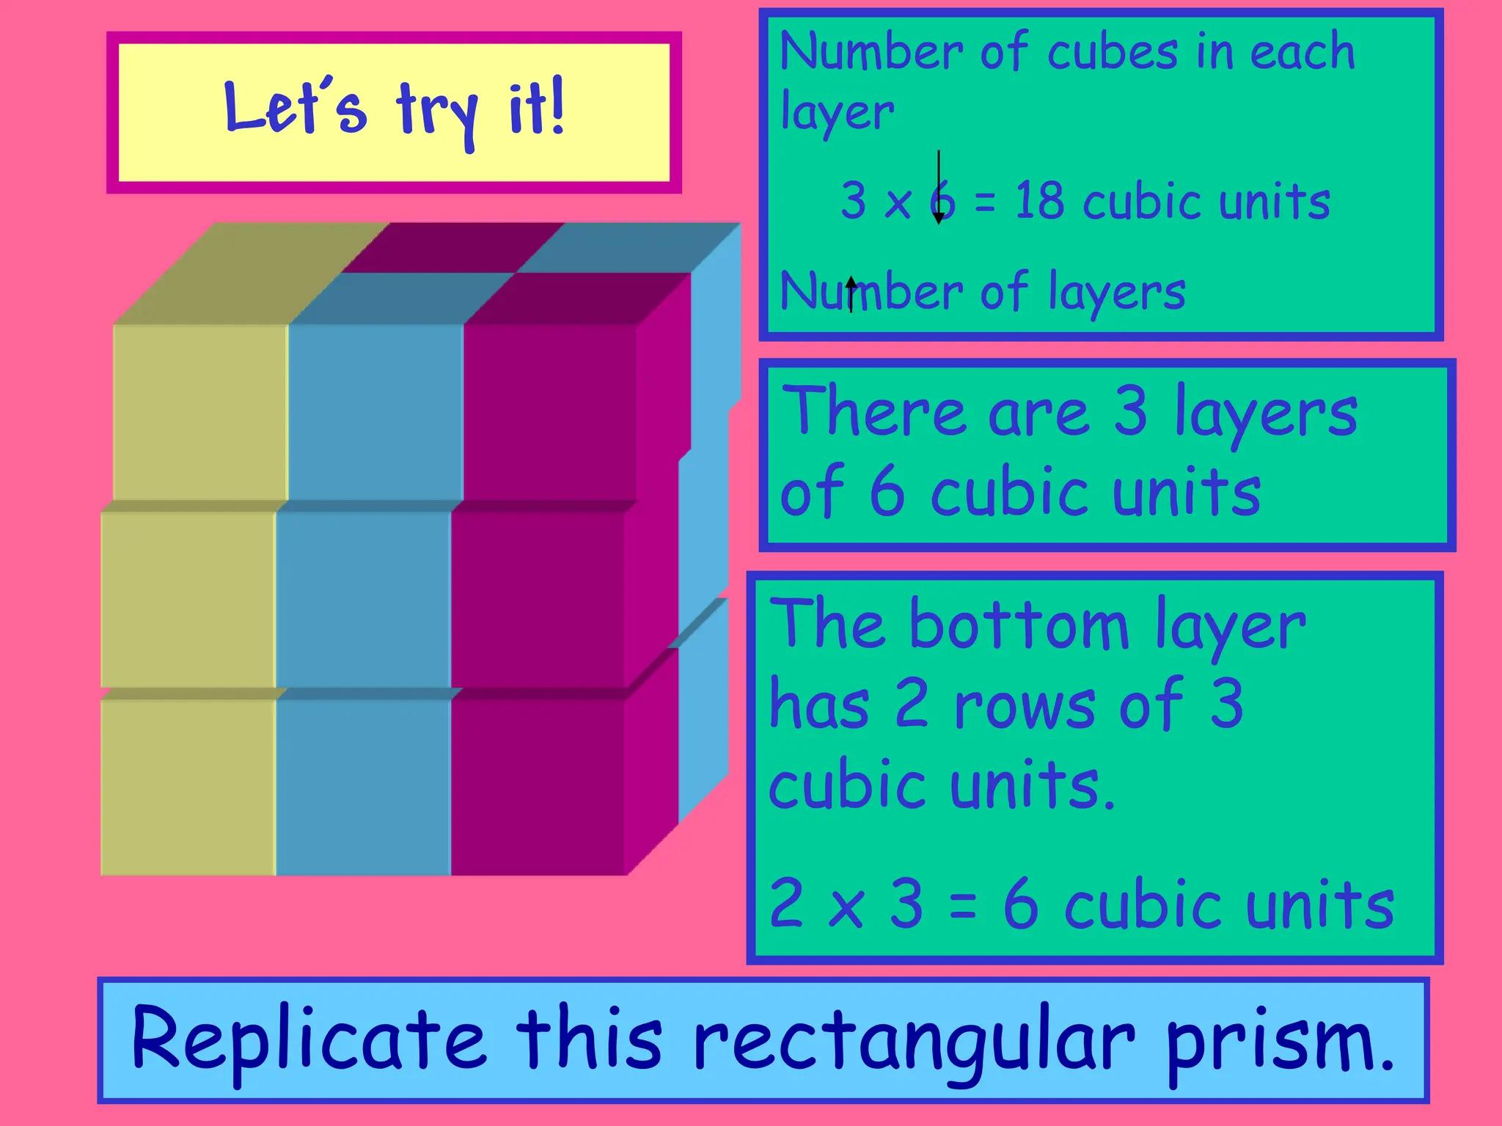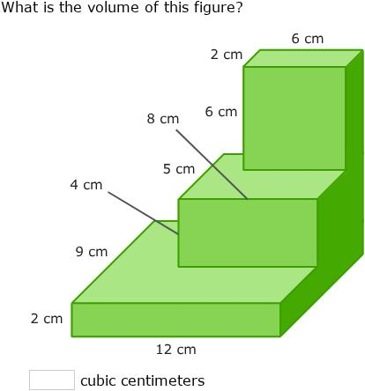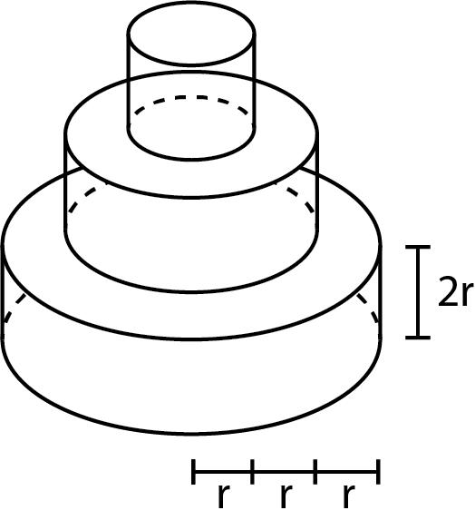
Basic structure:
- Bottom Layer: The lowest level of the composite solid.
- Middle Layers: One or more intermediate levels.
- Top Layer: The highest level.
- Layer Interface: The contact region between two successive layers.
- Overall Height: The total vertical dimension of all layers.

Main Classification
# Source: AI Source: Provided by: [Data Path: Persons Table -> ID Column: 1, Name_En Column: Motasem Essam] -> From: [ChatGPT] on [7/25/2026]
Layered arrangements can be classified according to the number of layers, component arrangement, layer dimensions, and geometric patterns.

Classification by Number of Layers
# Source: AI Source: Provided by: [Data Path: Persons Table -> ID Column: 1, Name_En Column: Motasem Essam] -> From: [ChatGPT] on [7/25/2026]
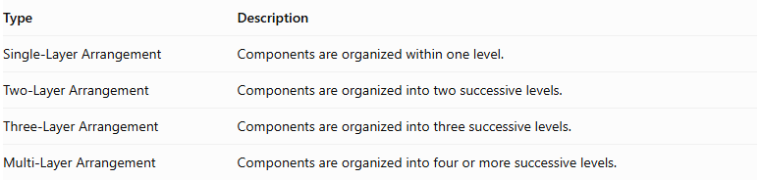
Type | Description
Single-Layer Arrangement | Components are organized within one level.
Two-Layer Arrangement | Components are organized into two successive levels.
Three-Layer Arrangement | Components are organized into three successive levels.
Multi-Layer Arrangement | Components are organized into four or more successive levels.
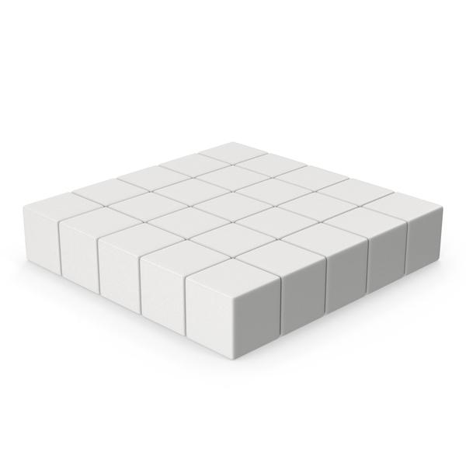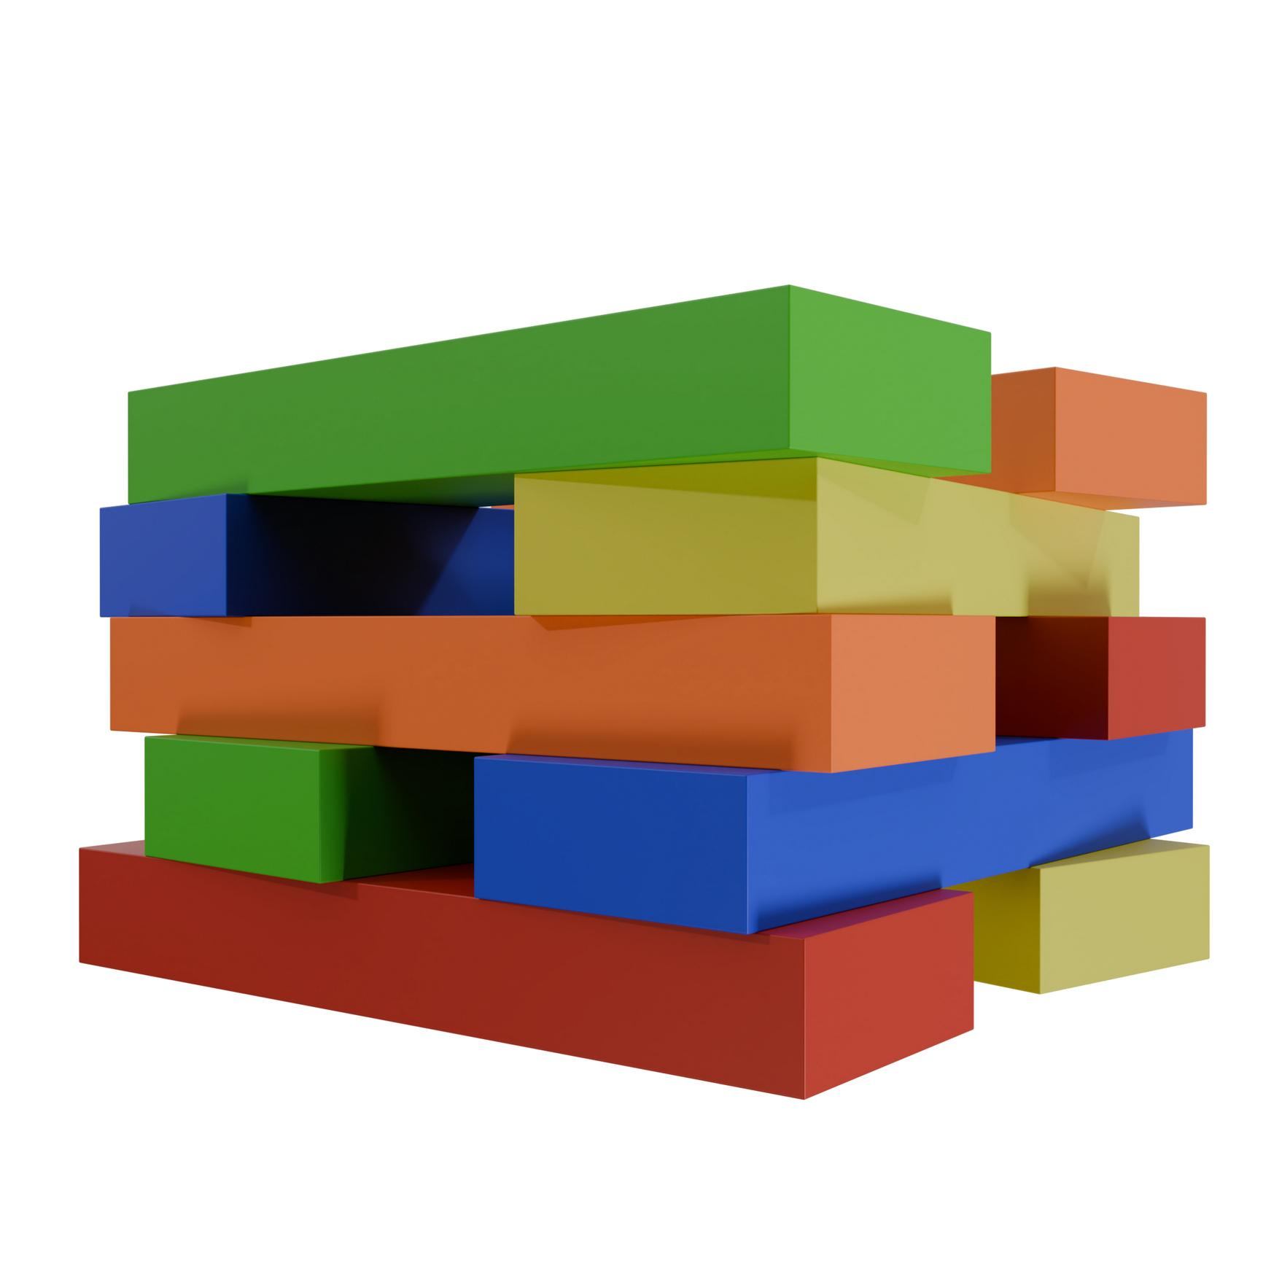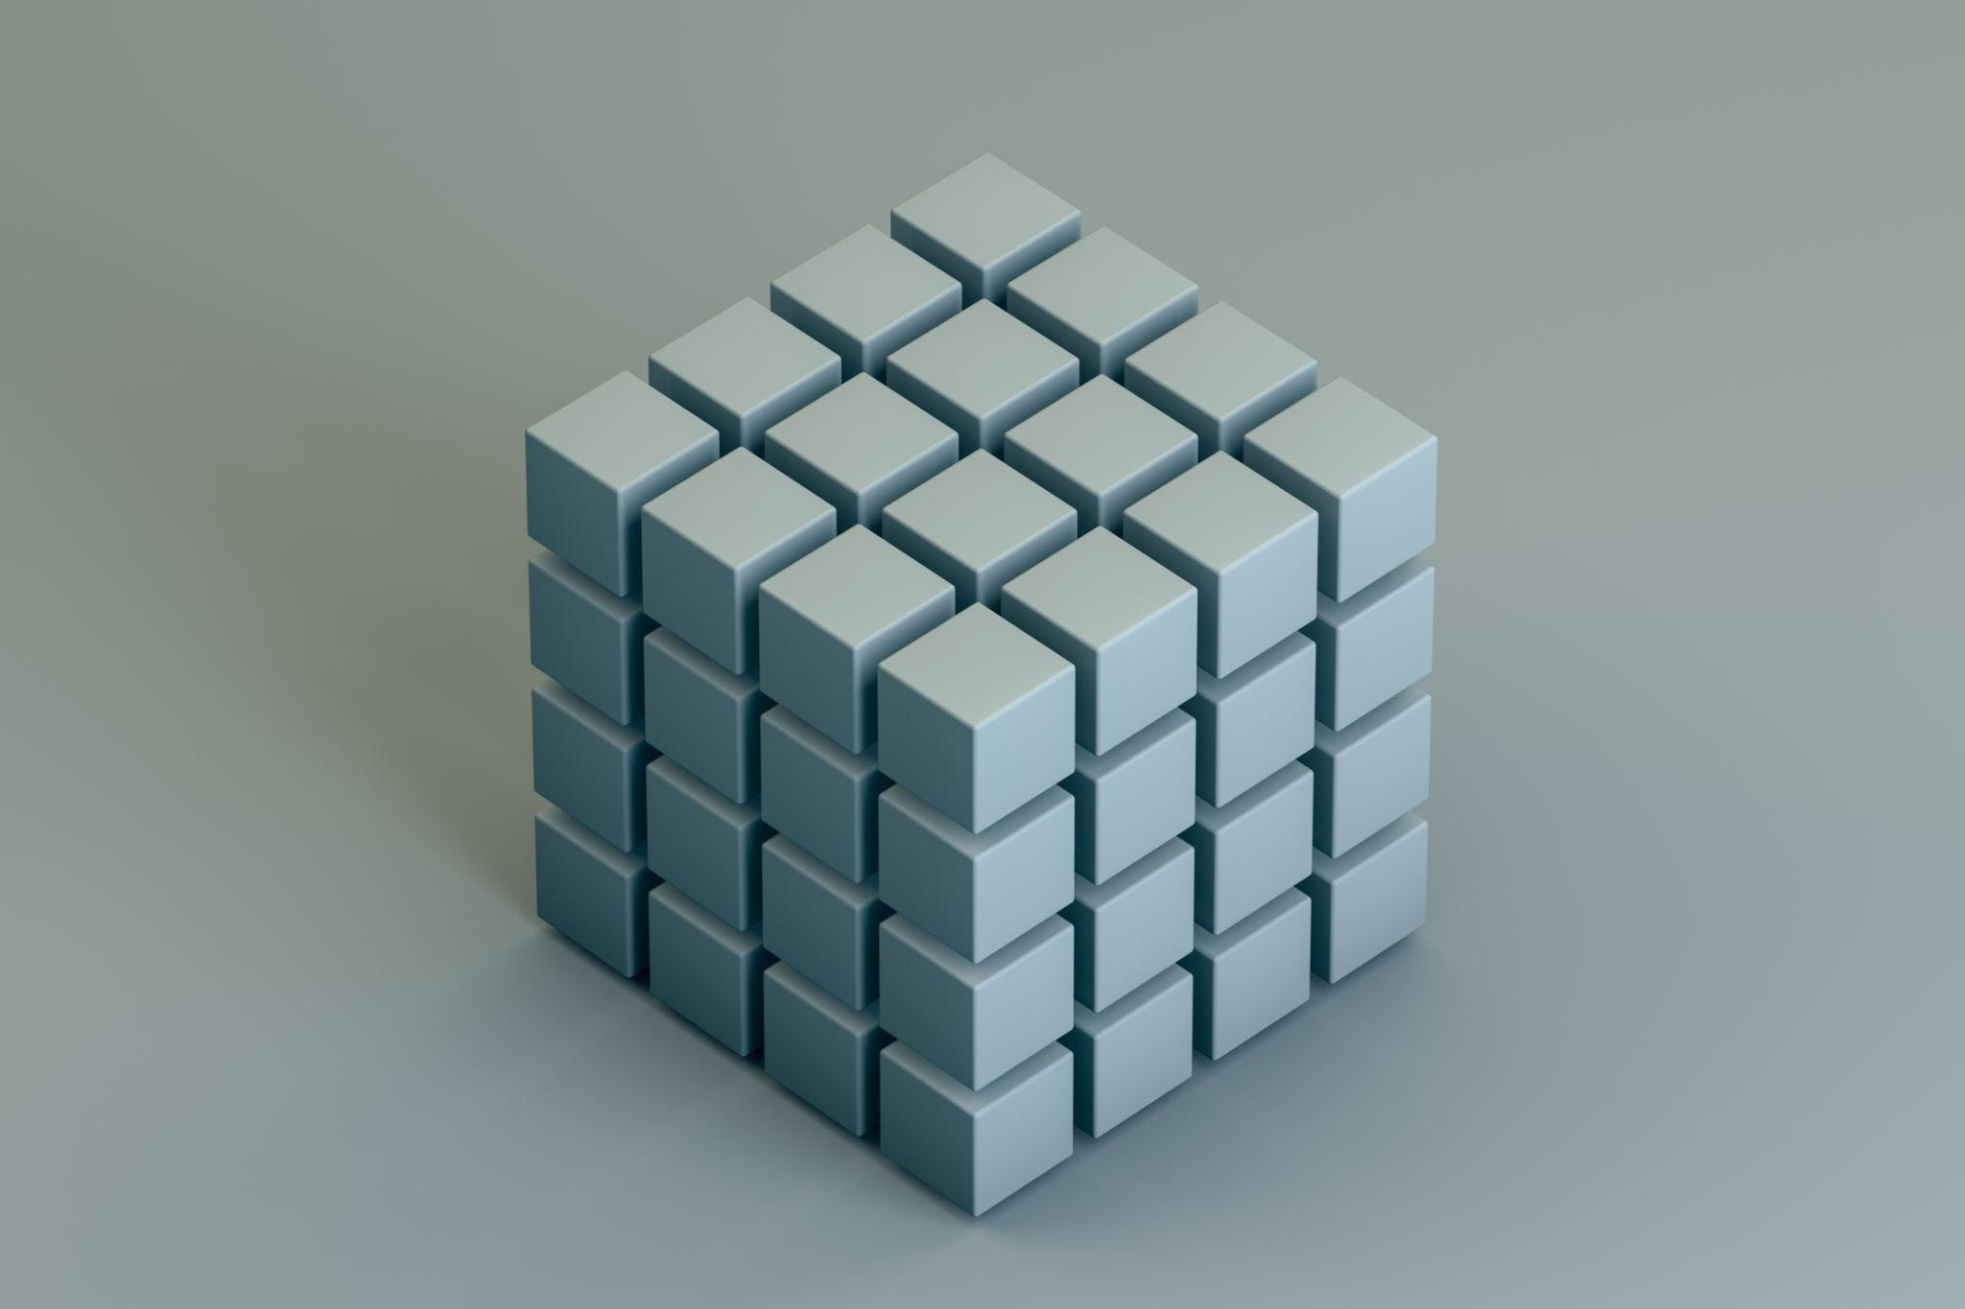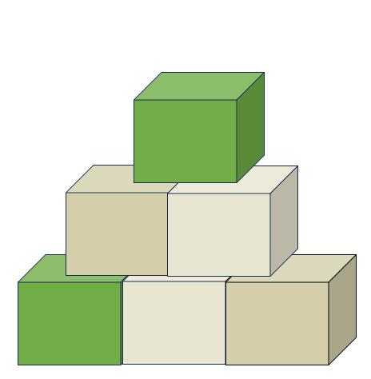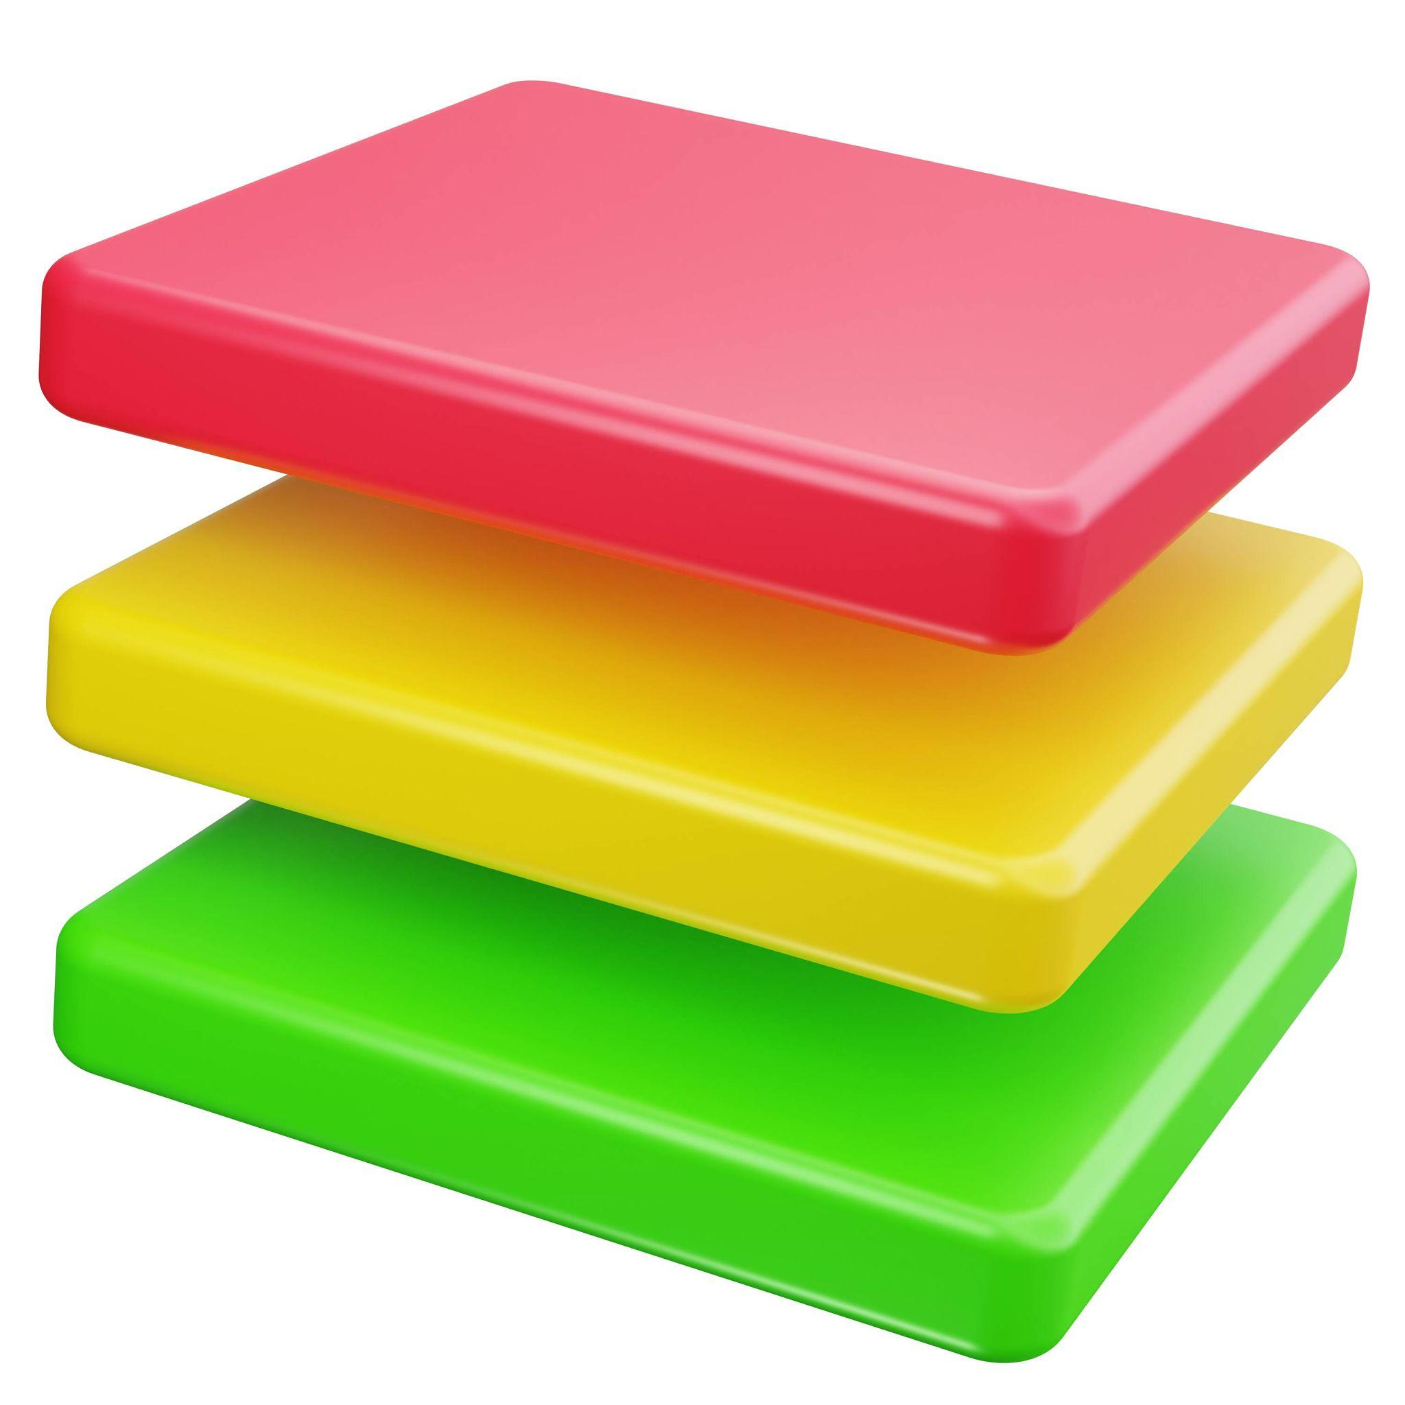

Classification by Layer Alignment
# Source: AI Source: Provided by: [Data Path: Persons Table -> ID Column: 1, Name_En Column: Motasem Essam] -> From: [ChatGPT] on [7/25/2026]
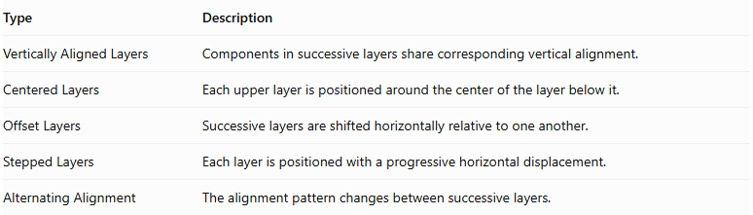
Type | Description
Vertically Aligned Layers | Components in successive layers share corresponding vertical alignment.
Centered Layers | Each upper layer is positioned around the center of the layer below it.
Offset Layers | Successive layers are shifted horizontally relative to one another.
Stepped Layers | Each layer is positioned with a progressive horizontal displacement.
Alternating Alignment | The alignment pattern changes between successive layers.
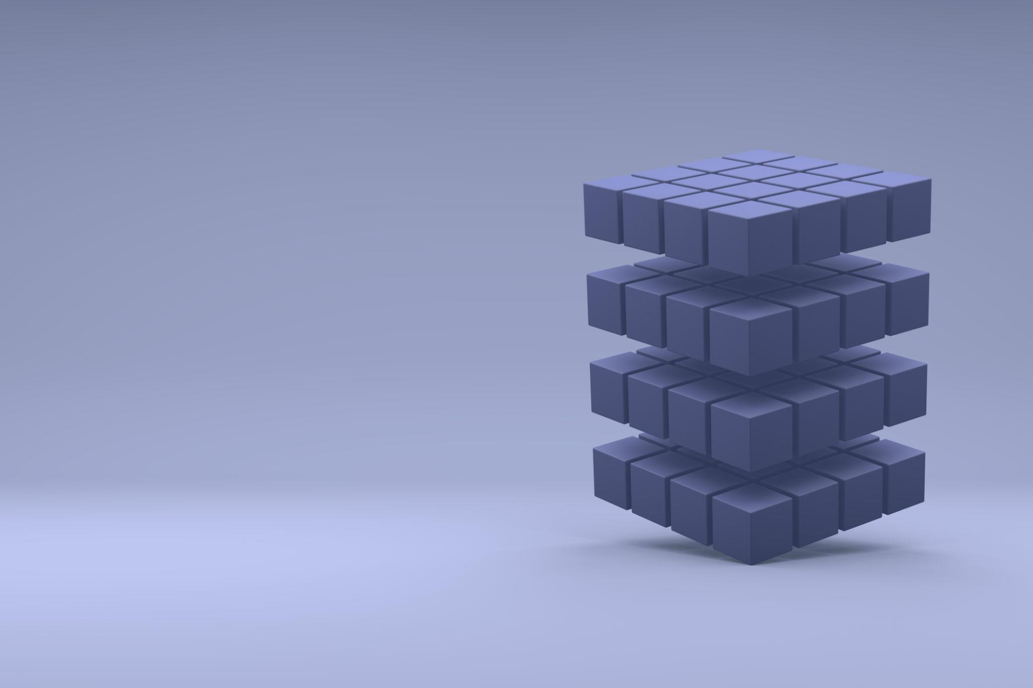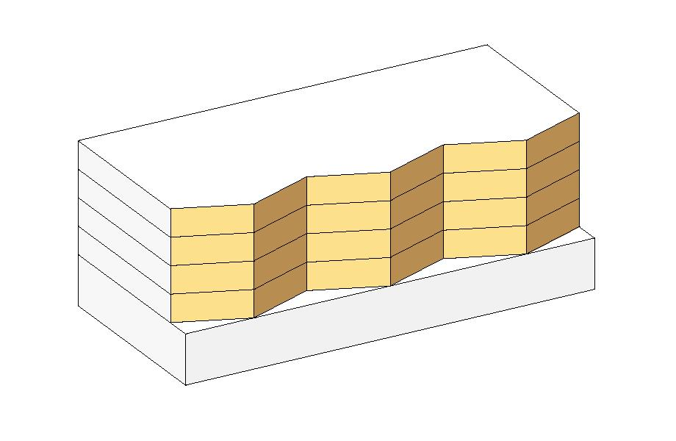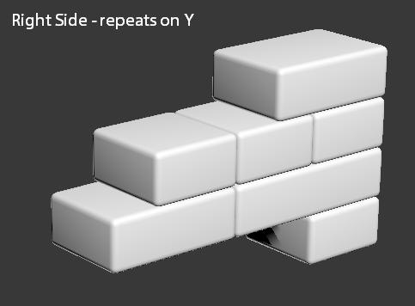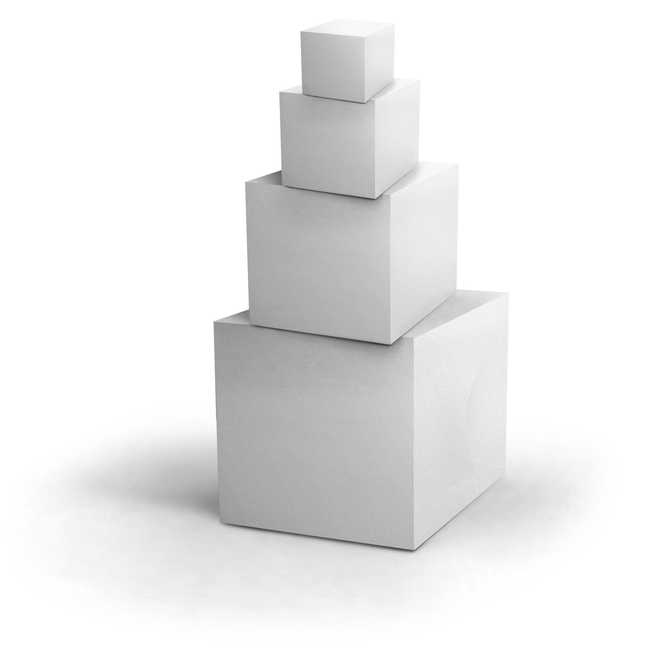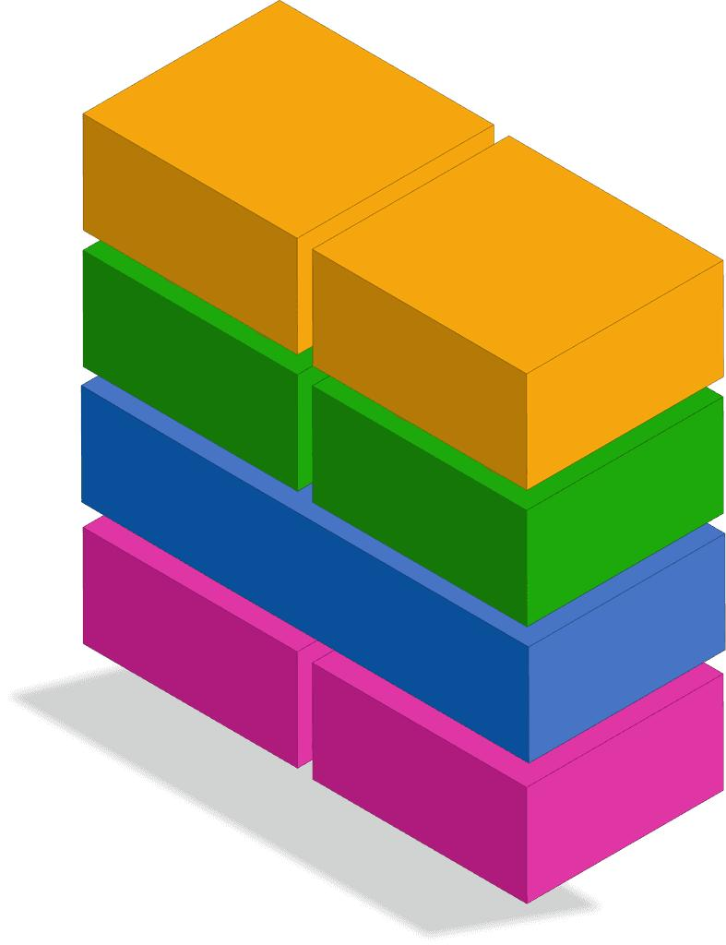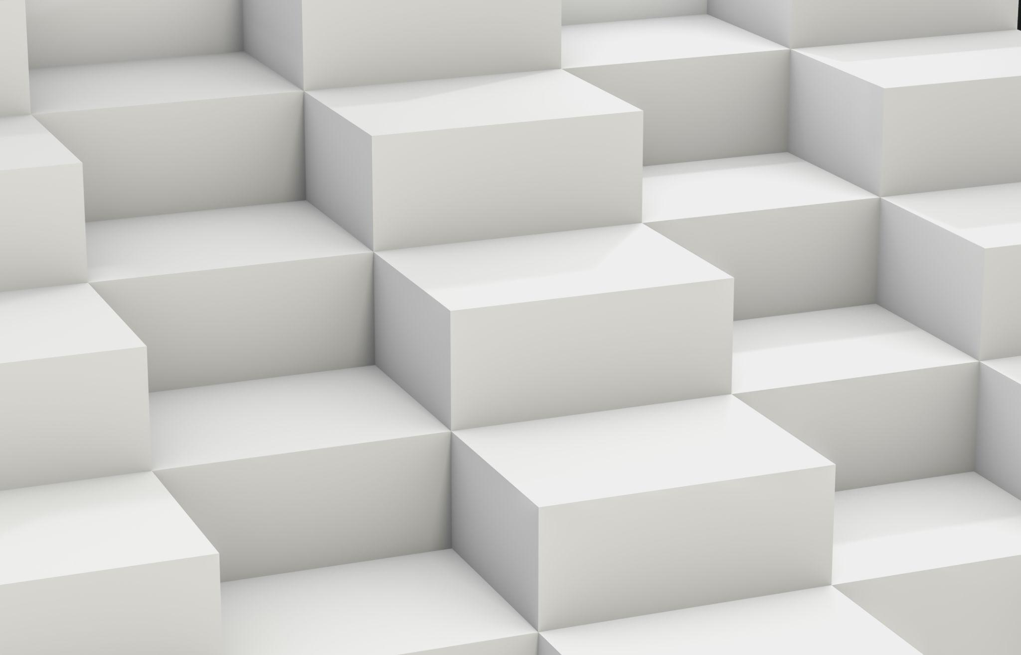

Classification by Component Distribution
# Source: AI Source: Provided by: [Data Path: Persons Table -> ID Column: 1, Name_En Column: Motasem Essam] -> From: [ChatGPT] on [7/25/2026]
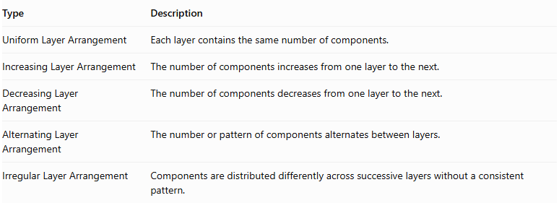
Type | Description
Uniform Layer Arrangement | Each layer contains the same number of components.
Increasing Layer Arrangement | The number of components increases from one layer to the next.
Decreasing Layer Arrangement | The number of components decreases from one layer to the next.
Alternating Layer Arrangement | The number or pattern of components alternates between layers.
Irregular Layer Arrangement | Components are distributed differently across successive layers without a consistent pattern.
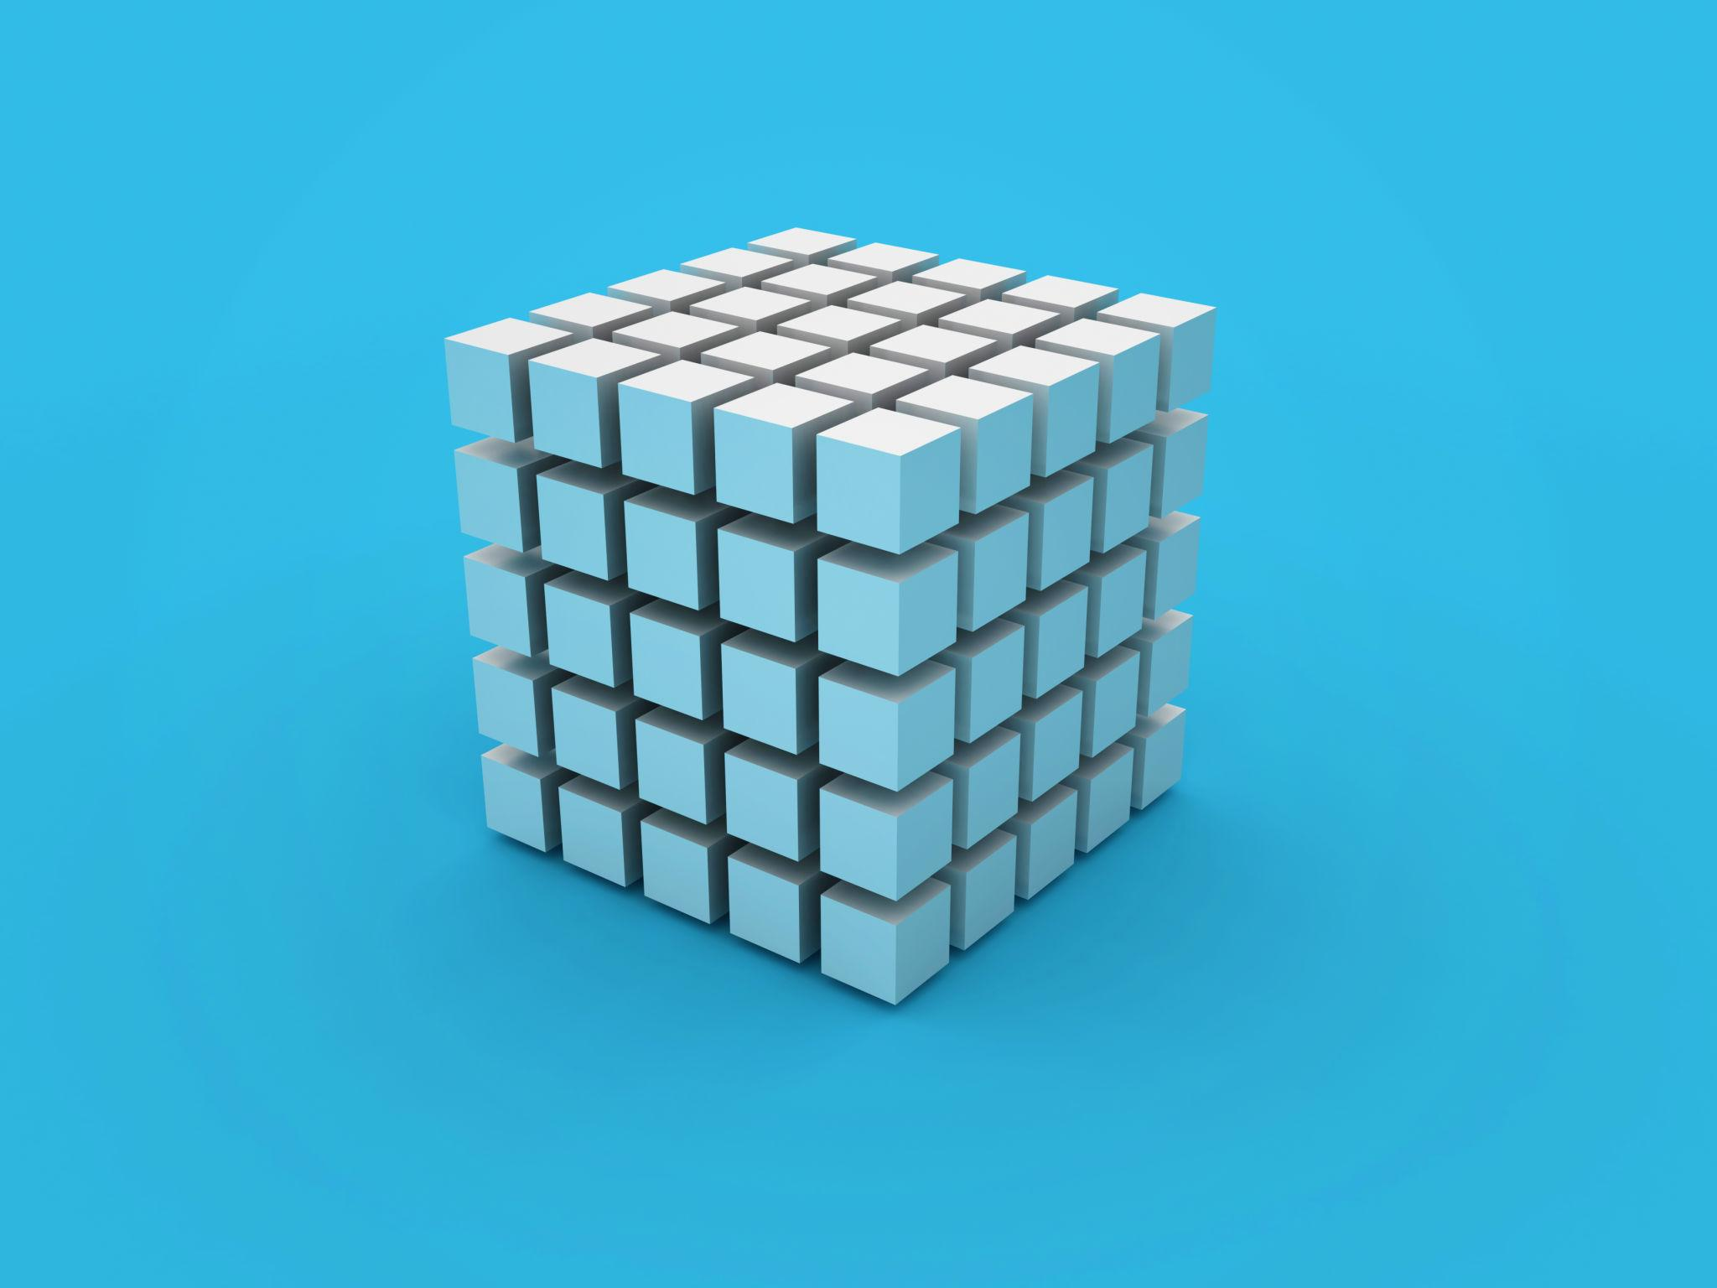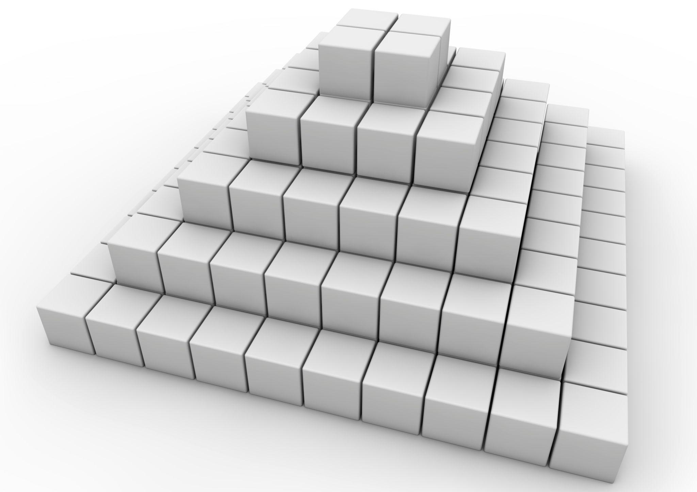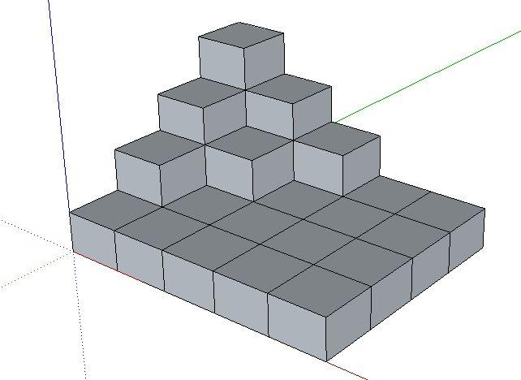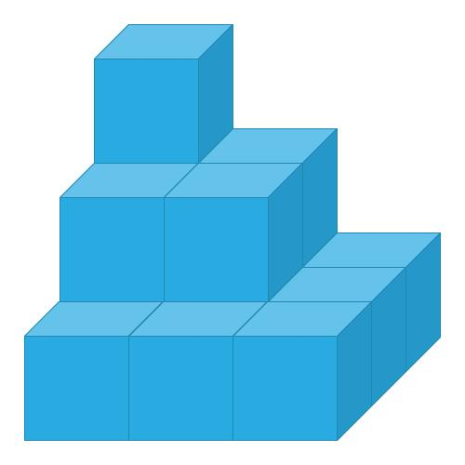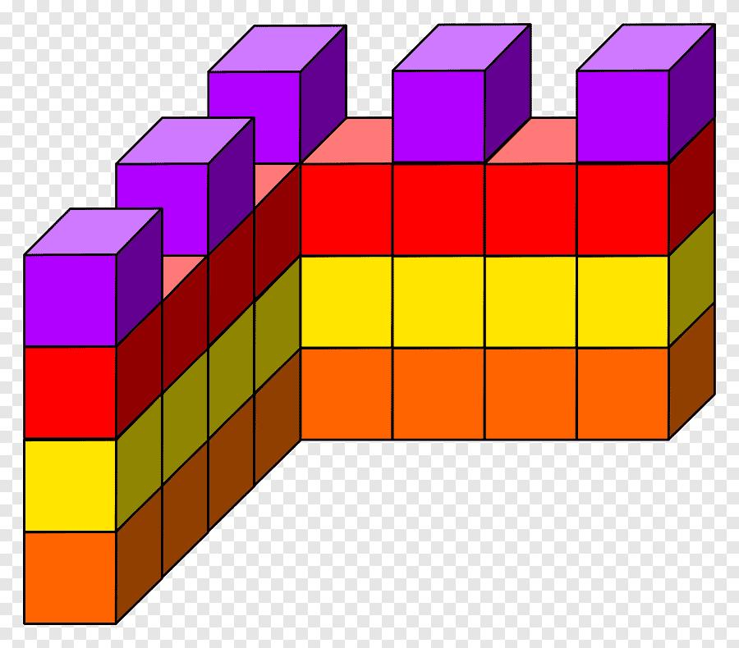

Classification by Layer Dimensions
# Source: AI Source: Provided by: [Data Path: Persons Table -> ID Column: 1, Name_En Column: Motasem Essam] -> From: [ChatGPT] on [7/25/2026]
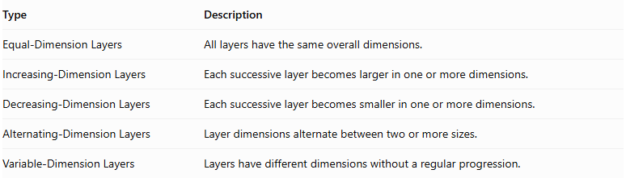
Type | Description
Equal-Dimension Layers | All layers have the same overall dimensions.
Increasing-Dimension Layers | Each successive layer becomes larger in one or more dimensions.
Decreasing-Dimension Layers | Each successive layer becomes smaller in one or more dimensions.
Alternating-Dimension Layers | Layer dimensions alternate between two or more sizes.
Variable-Dimension Layers | Layers have different dimensions without a regular progression.
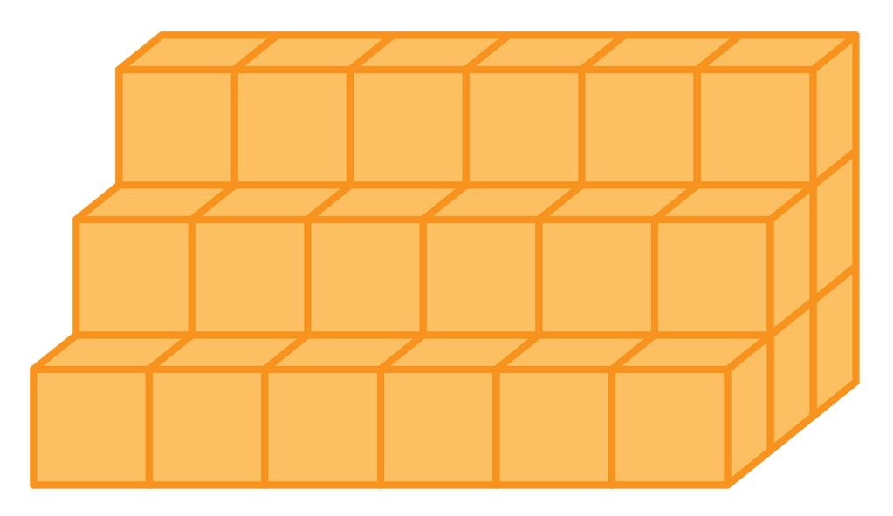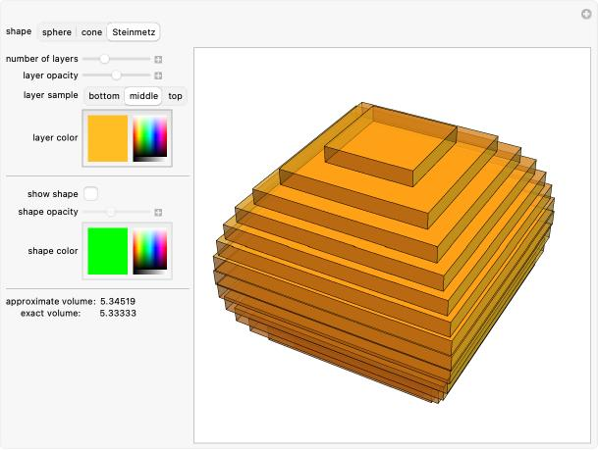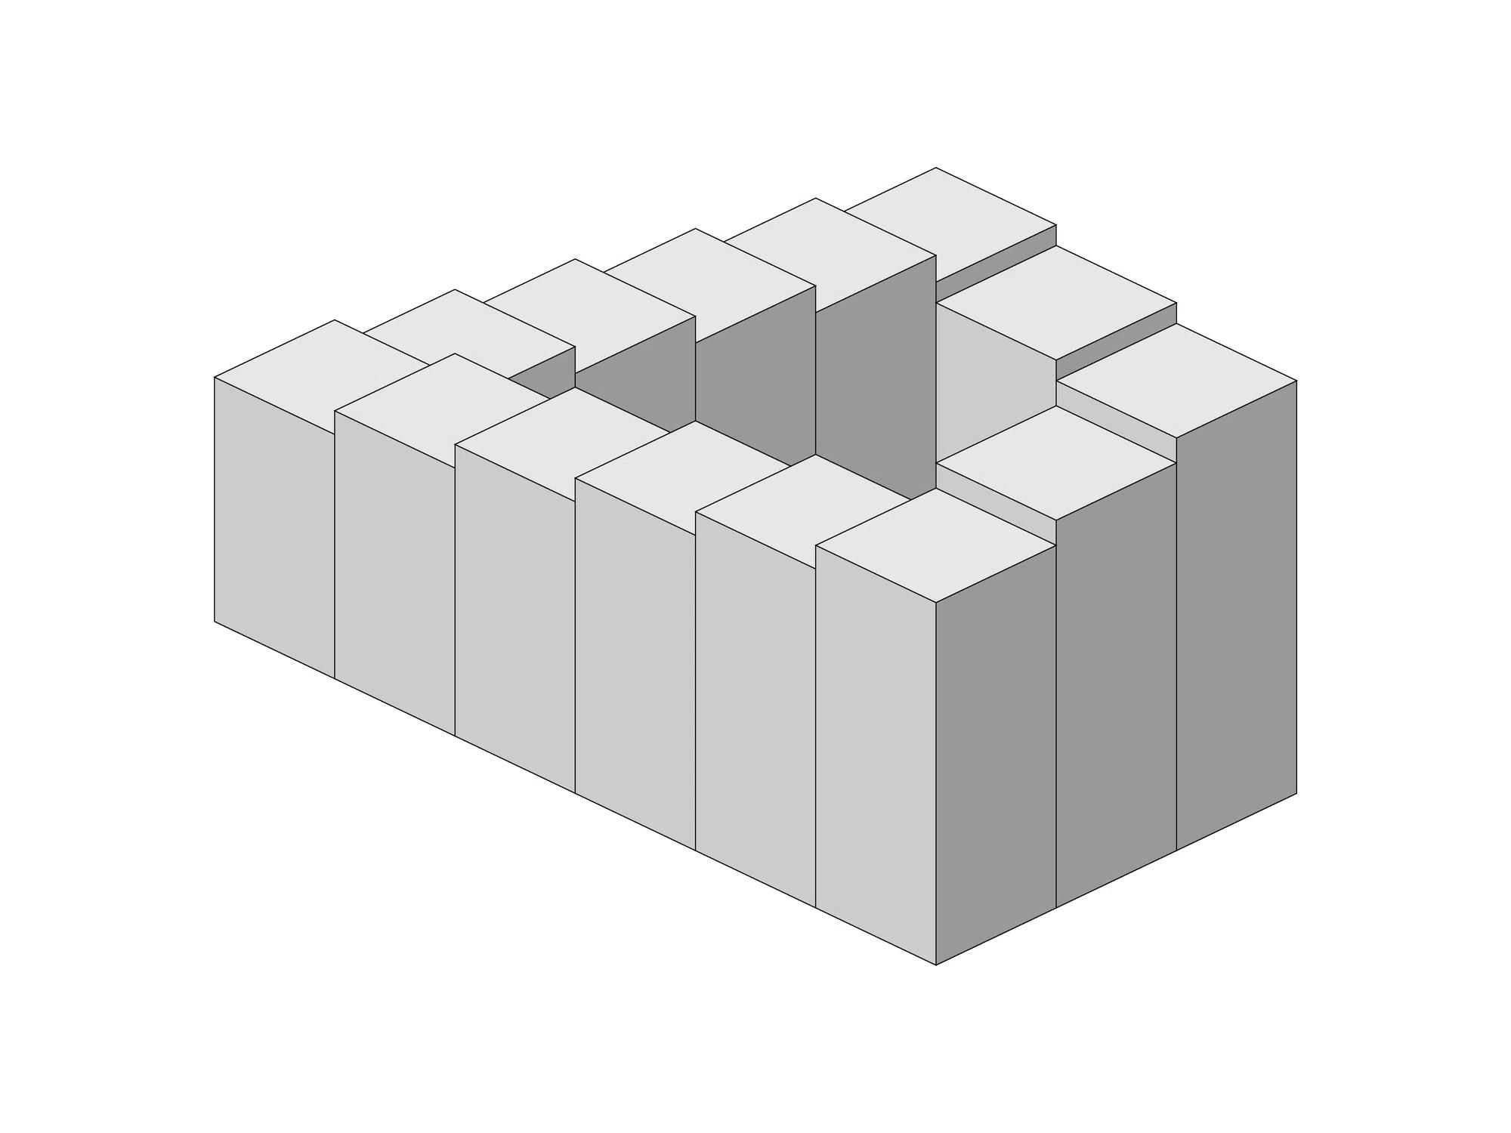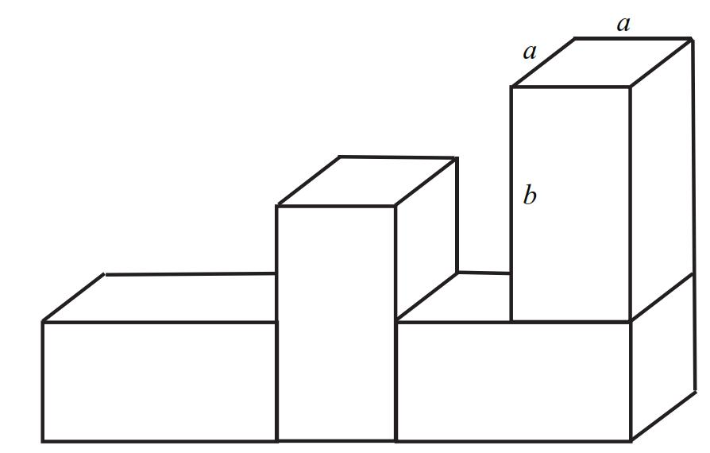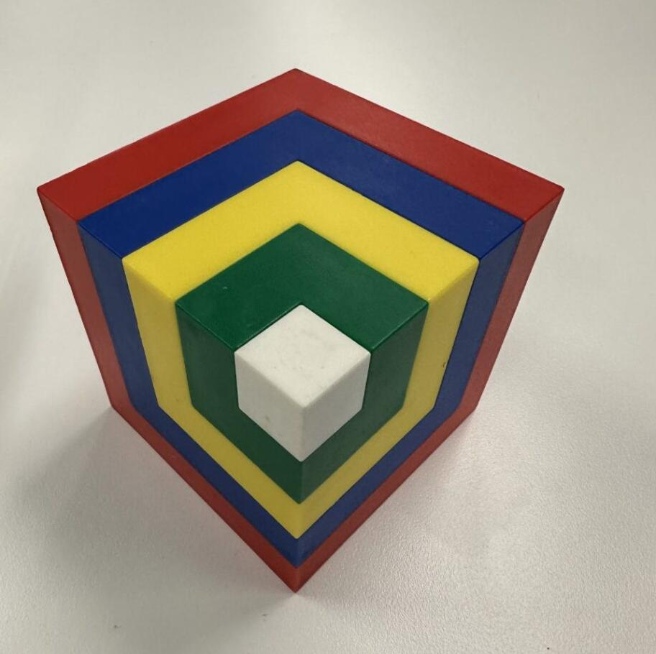

Classification by Layer Shape
# Source: AI Source: Provided by: [Data Path: Persons Table -> ID Column: 1, Name_En Column: Motasem Essam] -> From: [ChatGPT] on [7/25/2026]
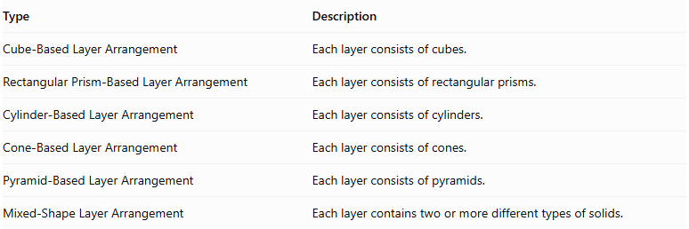
Type | Description
Cube-Based Layer Arrangement | Each layer consists of cubes.
Rectangular Prism-Based Layer Arrangement | Each layer consists of rectangular prisms.
Cylinder-Based Layer Arrangement | Each layer consists of cylinders.
Cone-Based Layer Arrangement | Each layer consists of cones.
Pyramid-Based Layer Arrangement | Each layer consists of pyramids.
Mixed-Shape Layer Arrangement | Each layer contains two or more different types of solids.
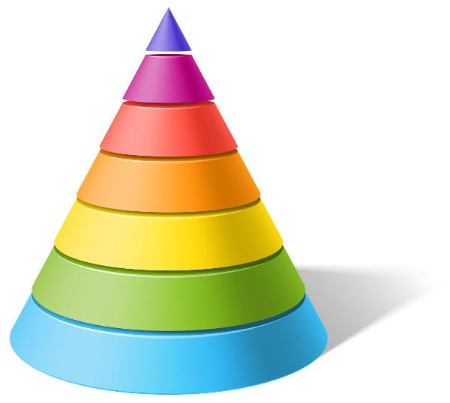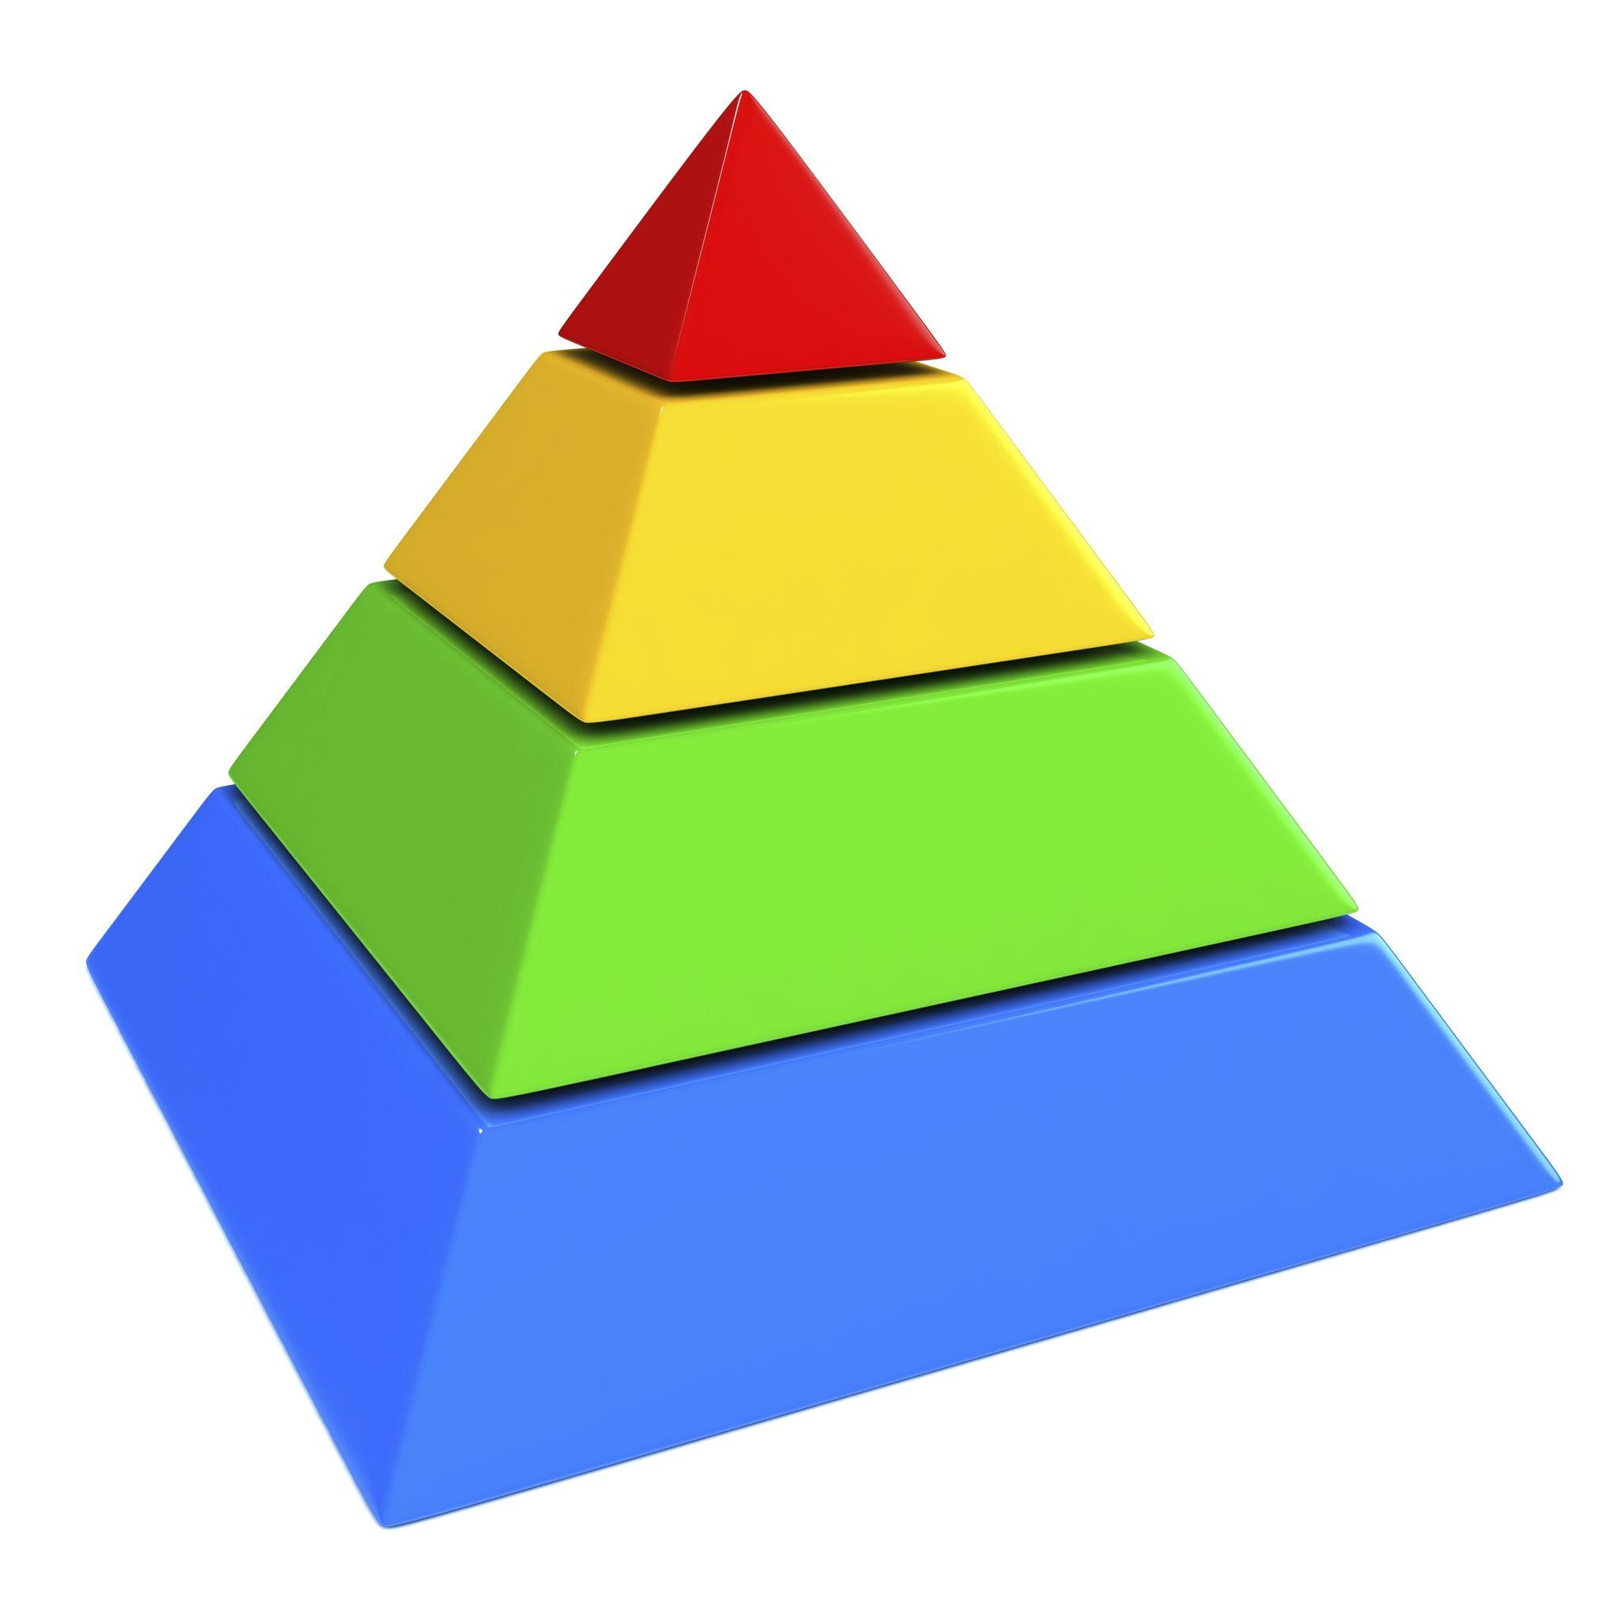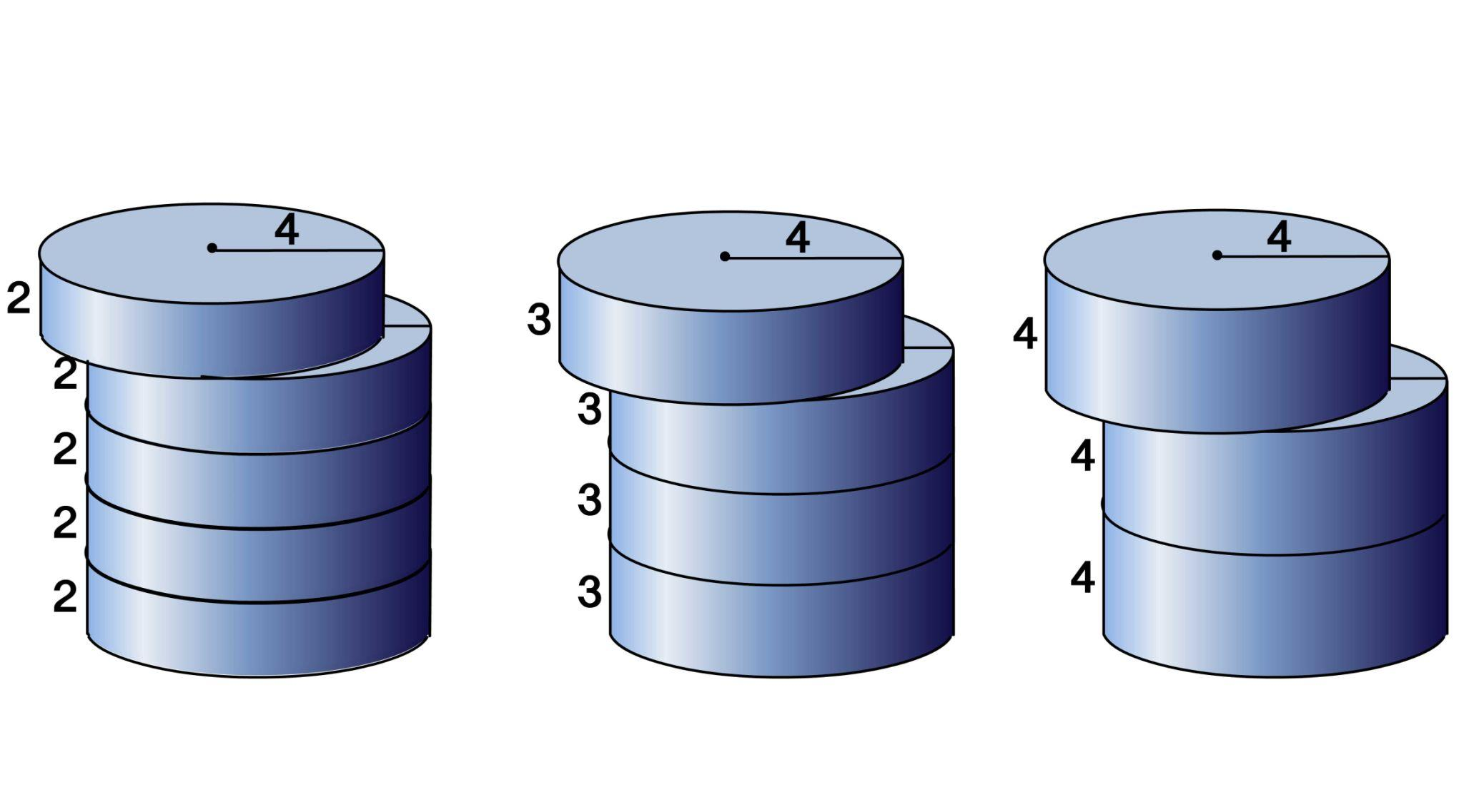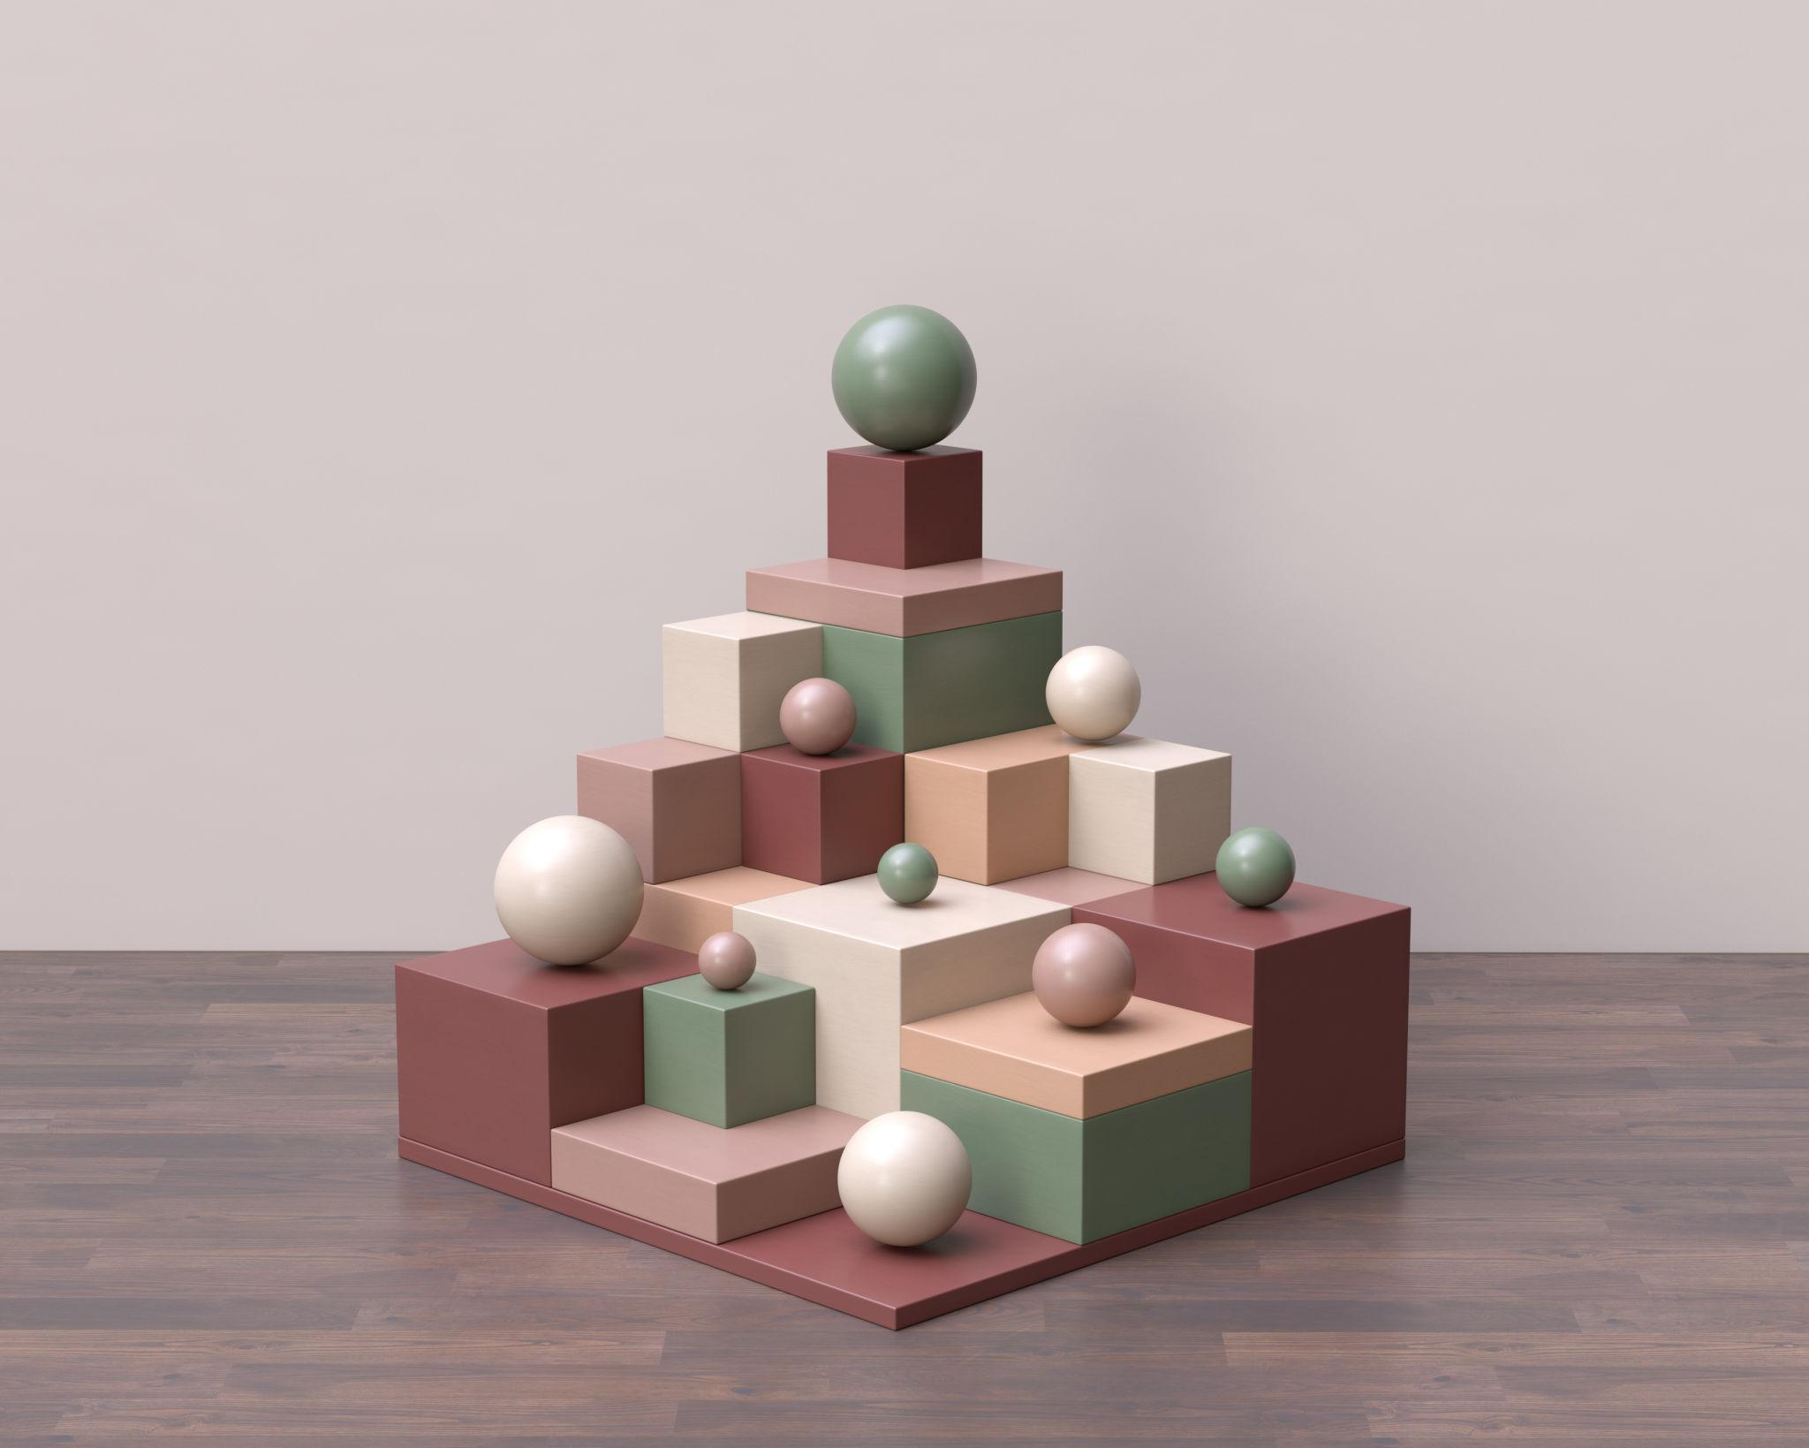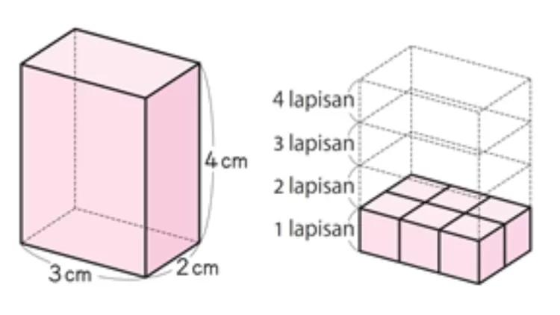

Classification by Layer Contact
# Source: AI Source: Provided by: [Data Path: Persons Table -> ID Column: 1, Name_En Column: Motasem Essam] -> From: [ChatGPT] on [7/25/2026]
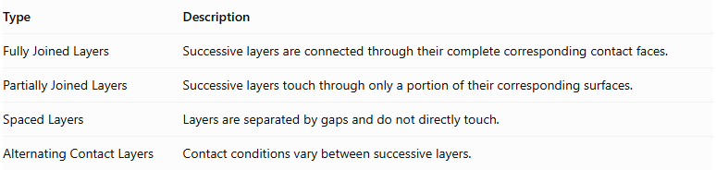
Type | Description
Fully Joined Layers | Successive layers are connected through their complete corresponding contact faces.
Partially Joined Layers | Successive layers touch through only a portion of their corresponding surfaces.
Spaced Layers | Layers are separated by gaps and do not directly touch.
Alternating Contact Layers | Contact conditions vary between successive layers.
Important: Spaced layers may form a layered assembly, but they are not necessarily one physically connected solid.

Mathematical Properties and Formulas

Total Number of Components
# Source: AI Source: Provided by: [Data Path: Persons Table -> ID Column: 1, Name_En Column: Motasem Essam] -> From: [ChatGPT] on [7/25/2026]
If each layer contains a different number of components:
$$N_{total}=\sum_{i=1}^{L}{N_{i}}$$
Where:
- $N_{total}$ = Total number of components.
- $L$ = Number of layers.
- $N_{i}$ = Number of components in layer $i$.
If every layer contains the same number of components:
$$N_{total}=L×N$$

Total Volume
# Source: AI Source: Provided by: [Data Path: Persons Table -> ID Column: 1, Name_En Column: Motasem Essam] -> From: [ChatGPT] on [7/25/2026]
For non-overlapping components:
$$V_{total}=\sum_{i=1}^{L}{V_{i}}$$
For identical components:
$$V_{total}=N_{total}×V_{component}$$

Overall Height
# Source: AI Source: Provided by: [Data Path: Persons Table -> ID Column: 1, Name_En Column: Motasem Essam] -> From: [ChatGPT] on [7/25/2026]
For successive layers arranged vertically without overlap:
$$H_{total}=\sum_{i=1}^{L}{h_{i}}$$
For layers with equal heights:
$$H_{total}=L×h$$
If equal vertical gaps separate the layers:
$$H_{total}=\sum_{i=1}^{L}{h_{i}}+(L-1)g$$
Where $g$ represents the vertical gap between successive layers.

External Surface Area
# Source: AI Source: Provided by: [Data Path: Persons Table -> ID Column: 1, Name_En Column: Motasem Essam] -> From: [ChatGPT] on [7/25/2026]
The external surface area is calculated by adding the exposed surfaces of all components and excluding their hidden contact regions.
For components joined through complete matching planar faces:
$${SA}_{external}=\sum{{SA}_{i}}-2\sum{A_{interface}}$$
Where:
- ${SA}_{i}$ = Surface area of each individual component.
- $A_{interface}$ = Area of a shared contact face.
For partial contact, subtract the actual hidden contact region from each affected component's surface area. Curved or irregular contact regions may require separate geometric calculations.

Worked Examples

Example 1: Three Layers of Cubes
# Source: AI Source: Provided by: [Data Path: Persons Table -> ID Column: 1, Name_En Column: Motasem Essam] -> From: [ChatGPT] on [7/25/2026]
Problem:
A composite solid consists of three horizontal layers, each containing four identical cubes. Each cube has a side length of 3 cm. All cubes are joined face-to-face.
Calculate:
- The total number of cubes.
- The total volume.
- The overall height.
- The external surface area.
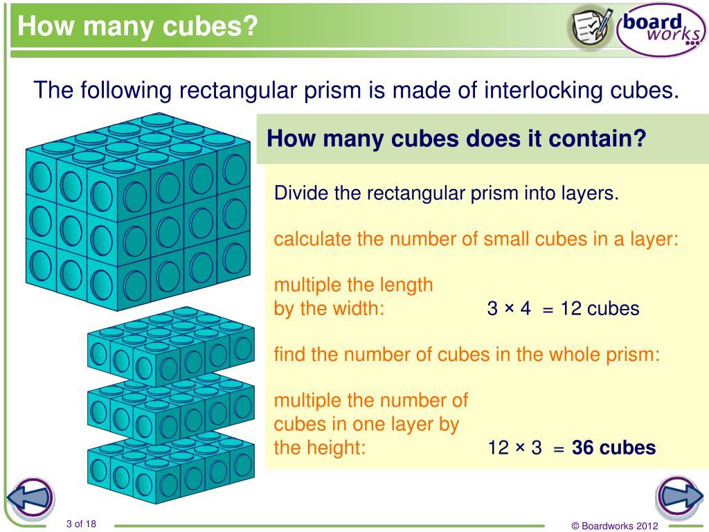
Step 1: Calculate the total number of cubes.
$$N=3×4=12$$
Step 2: Calculate the volume of one cube.
$$V_{cube}=s^{3}$$
$$V_{cube}=3^{3}=27{ cm}^{3}$$
Step 3: Calculate the total volume.
$$V_{total}=12×27$$
$$\boxed{V_{total}=324{ cm}^{3}}$$
Step 4: Calculate the overall height.
$$H=3×3$$
$$\boxed{H=9 cm}$$
Step 5: Calculate the external surface area.
The arrangement forms a rectangular prism with dimensions:
$$12×3×9$$
Therefore:
$$SA=2(lw+lh+wh)$$
$$SA=2(12×3+12×9+3×9)$$
$$SA=2(36+108+27)$$
$$\boxed{SA=342{ cm}^{2}}$$

Example 2: Three Layers of Cylinders with Different Radii
# Source: AI Source: Provided by: [Data Path: Persons Table -> ID Column: 1, Name_En Column: Motasem Essam] -> From: [ChatGPT] on [7/25/2026]
Problem:
A composite solid consists of three centered cylindrical layers arranged vertically.
- Bottom cylinder: radius 4 cm, height 5 cm.
- Middle cylinder: radius 3 cm, height 4 cm.
- Top cylinder: radius 2 cm, height 3 cm.
The cylinders are joined through their circular bases.
Calculate:
- The total volume.
- The overall height.
- The external surface area.
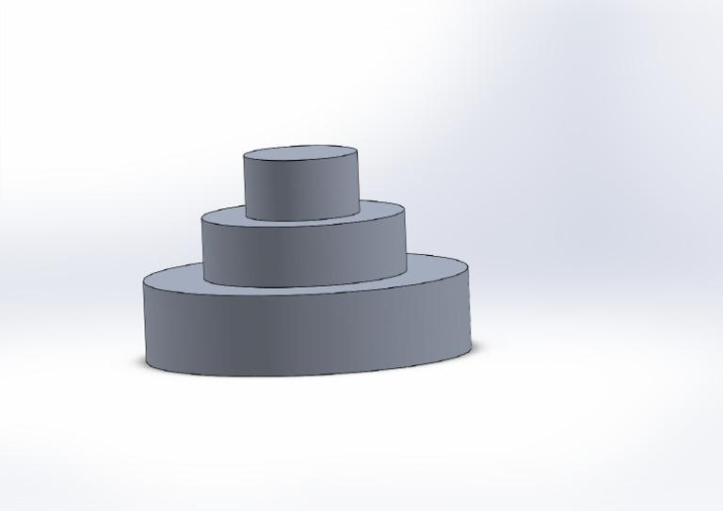
Step 1: Calculate the volume of each cylinder.
Formula:
$$V=πr^{2}h$$
Bottom cylinder:
$$V_{1}=π(4)^{2}(5)=80π$$
Middle cylinder:
$$V_{2}=π(3)^{2}(4)=36π$$
Top cylinder:
$$V_{3}=π(2)^{2}(3)=12π$$
Step 2: Calculate the total volume.
$$V_{total}=80π+36π+12π$$
$$\boxed{V_{total}=128π≈402.12{ cm}^{3}}$$
Step 3: Calculate the overall height.
$$H=5+4+3$$
$$\boxed{H=12 cm}$$
Step 4: Calculate the external surface area.
The exposed surfaces include:
- Curved lateral surface of all three cylinders.
- Bottom circular face of the bottom cylinder.
- Top circular face of the top cylinder.
- Exposed annular regions at the two interfaces.
The curved lateral areas are:
$${SA}_{lateral}=2πrh$$
$$=2π(4)(5)+2π(3)(4)+2π(2)(3)$$
$$=40π+24π+12π=76π$$
The exposed horizontal surfaces are:
$${SA}_{horizontal}=π(4^{2})+π(4^{2}-3^{2})+π(3^{2}-2^{2})+π(2^{2})$$
$$=π(16+7+5+4)=32π$$
Therefore:
$${SA}_{external}=76π+32π$$
$$\boxed{{SA}_{external}=108π≈339.29{ cm}^{2}}$$

Important Characteristics
# Source: AI Source: Provided by: [Data Path: Persons Table -> ID Column: 1, Name_En Column: Motasem Essam] -> From: [ChatGPT] on [7/25/2026]
- A layered arrangement contains two or more successive levels.
- Each layer may contain one or multiple solid components.
- Layers may have equal or different dimensions.
- The arrangement may be symmetrical or asymmetrical.
- Components may be aligned, centered, offset, or arranged irregularly.
- The number of components may remain constant or change between layers.
- Layer interfaces may be complete, partial, or absent.
- The overall height depends on the vertical dimensions and spacing of the layers.
- The total volume is the sum of component volumes when their interiors do not overlap.
- External surface area depends on the surfaces exposed after assembly.

Comparison with Other Component Arrangements
# Source: AI Source: Provided by: [Data Path: Persons Table -> ID Column: 1, Name_En Column: Motasem Essam] -> From: [ChatGPT] on [7/25/2026]
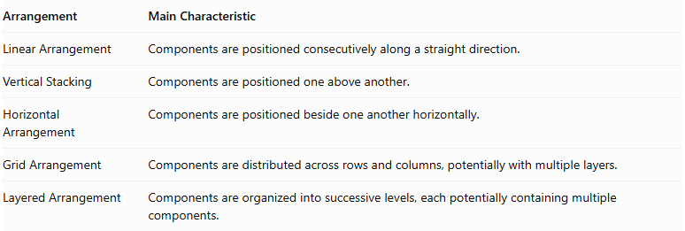
Arrangement | Main Characteristic
Linear Arrangement | Components are positioned consecutively along a straight direction.
Vertical Stacking | Components are positioned one above another.
Horizontal Arrangement | Components are positioned beside one another horizontally.
Grid Arrangement | Components are distributed across rows and columns, potentially with multiple layers.
Layered Arrangement | Components are organized into successive levels, each potentially containing multiple components.
Layered vs. Vertical Stacking: Vertical stacking focuses on the successive placement of individual components. Layered arrangement focuses on organizing components into distinct levels, where each level can contain several components.
Layered vs. Grid Arrangement: A grid arrangement describes the distribution of components across rows and columns. A layered arrangement describes the distribution across successive vertical levels. A solid can combine both classifications when each layer has a grid pattern.

Real-World Applications
# Source: AI Source: Provided by: [Data Path: Persons Table -> ID Column: 1, Name_En Column: Motasem Essam] -> From: [ChatGPT] on [7/25/2026]
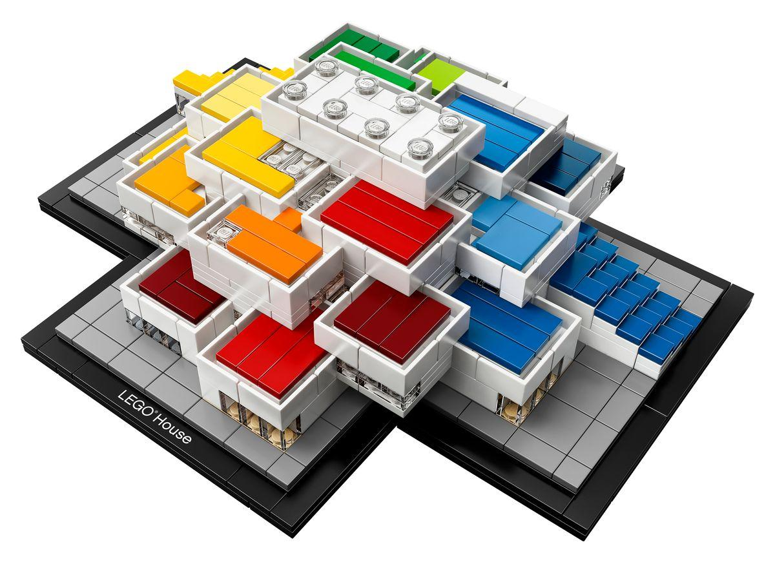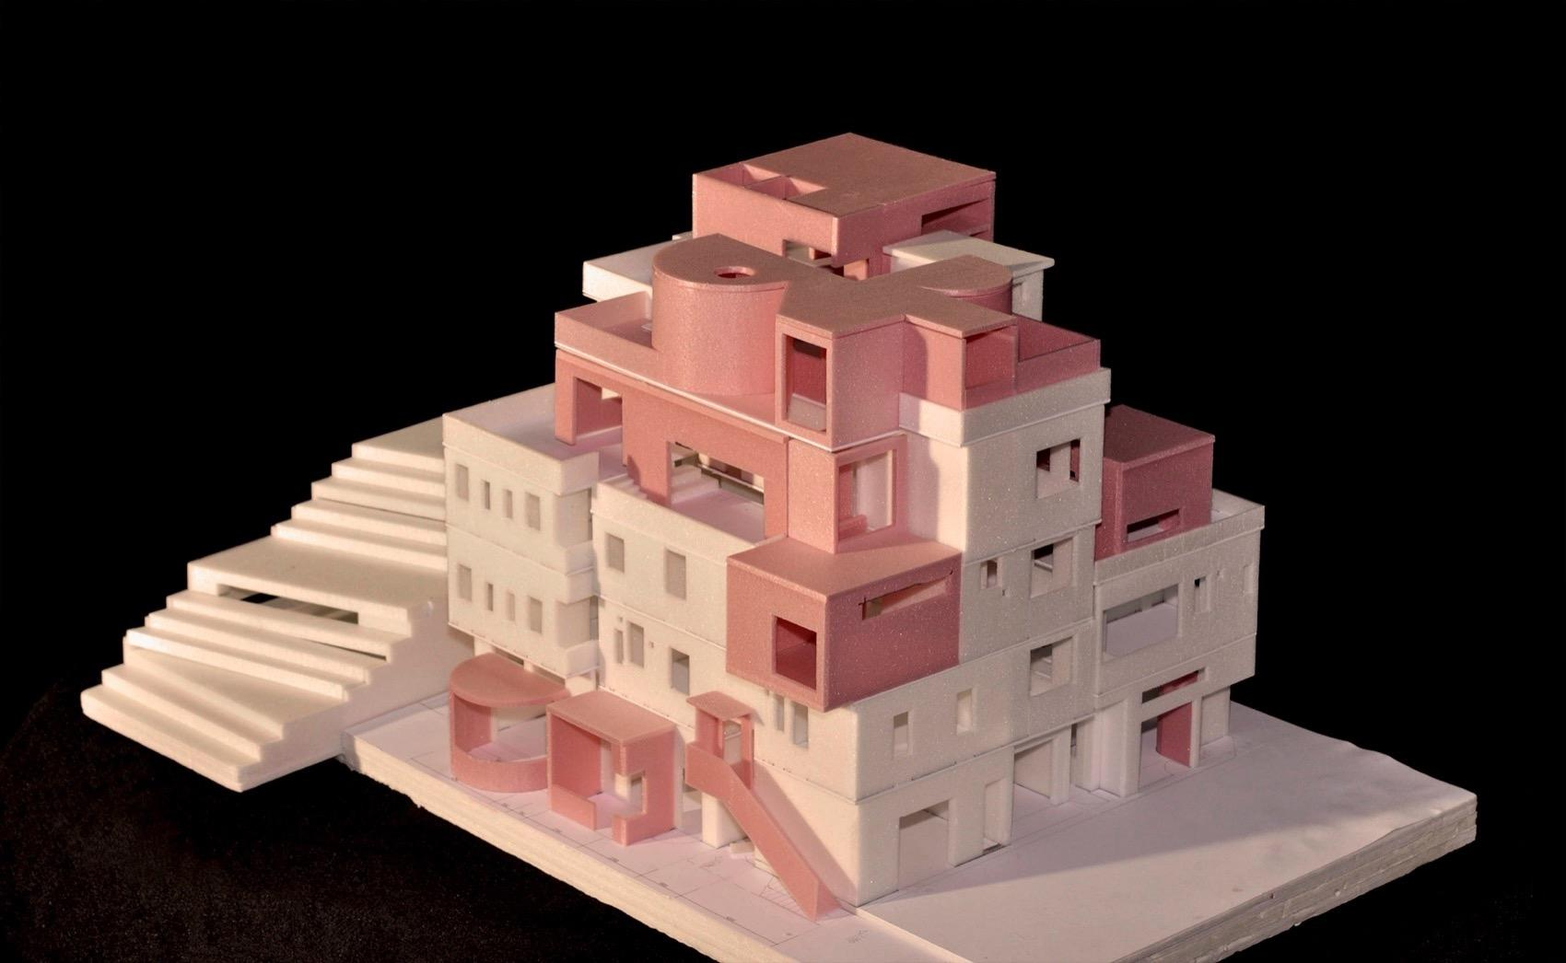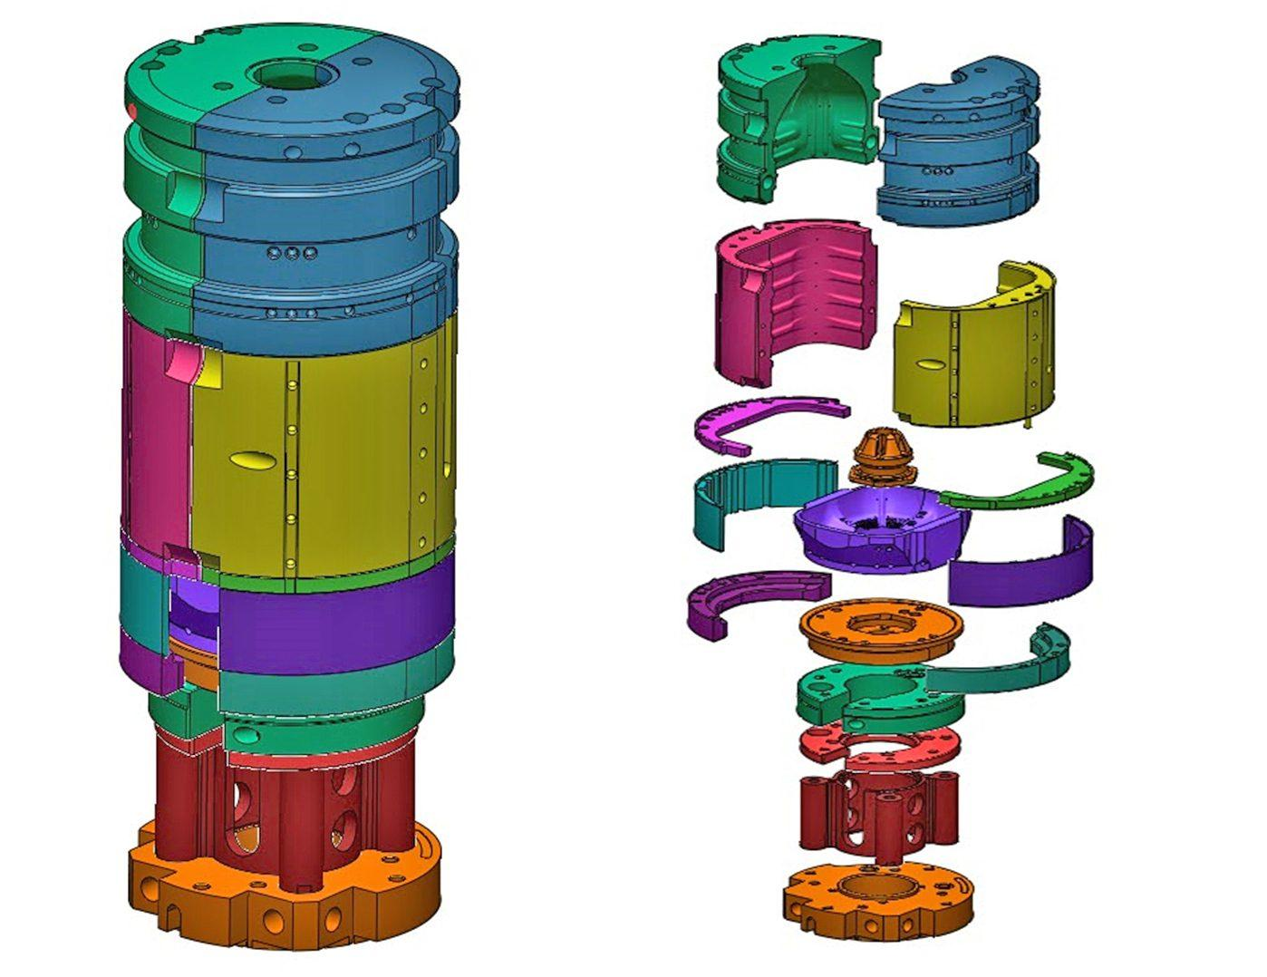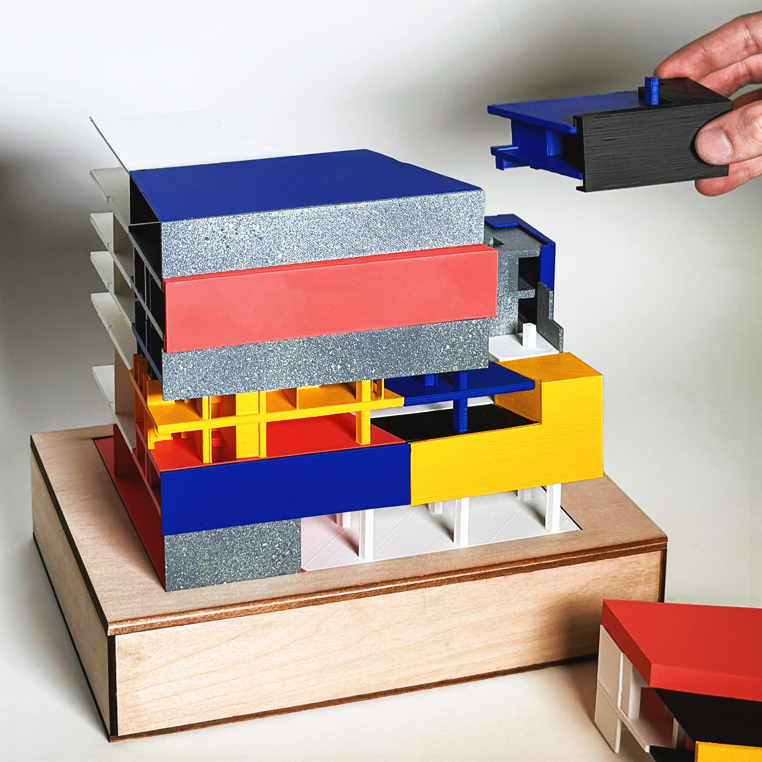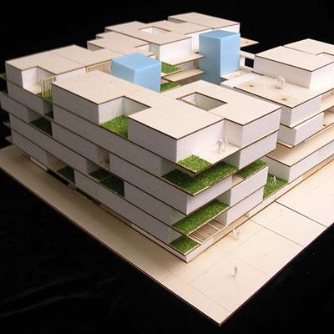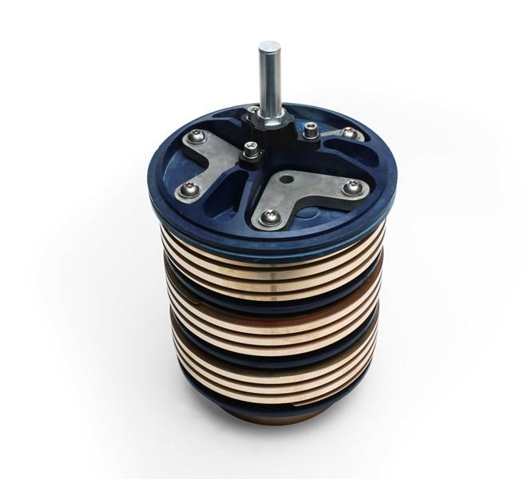
- Architecture: Buildings and structures composed of successive floors or levels.
- Construction: Brick walls and layered concrete structures.
- Manufacturing: Products assembled from stacked components.
- Mechanical Engineering: Cylindrical and other mechanical parts assembled in layers.
- Packaging: Products arranged in multiple stacked levels.
- Mathematical Modeling: Three-dimensional structures used to study volume, surface area, and spatial arrangements.

Key Points
# Source: AI Source: Provided by: [Data Path: Persons Table -> ID Column: 1, Name_En Column: Motasem Essam] -> From: [ChatGPT] on [7/25/2026]
- A layered arrangement organizes components into successive levels.
- Each layer may contain one or multiple components.
- Layers may be equal, increasing, decreasing, alternating, or irregular.
- Components may have identical or different geometric shapes.
- The total number of components is the sum of the components in all layers.
- The total height is the sum of layer heights and any vertical gaps.
- External surface area includes only exposed surfaces.
- A layered arrangement can also be a grid arrangement when its individual layers contain rows and columns.

Conclusion
# Source: AI Source: Provided by: [Data Path: Persons Table -> ID Column: 1, Name_En Column: Motasem Essam] -> From: [ChatGPT] on [7/25/2026]
A Layered Arrangement is a classification of composite solids based on the organization of their components into successive vertical levels. Each layer can contain one or more solids, with different arrangements, dimensions, shapes, and contact conditions.
This arrangement is particularly useful for describing complex three-dimensional structures in which multiple components are distributed across several levels.

